Biodiversity: Diversity in a Leaf Pack
TEACHER GUIDE

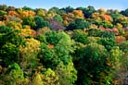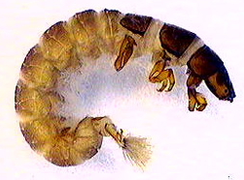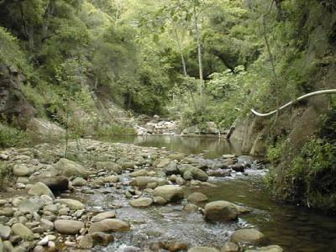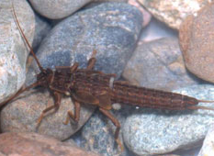

Written by: Jennifer Doherty and Cornelia Harris
With assistance from Andy Anderson, Marcia Angle, Mitch Burke, Terry Grant, Laurel Hartley, Michele Johnson, Shawna McMahon, John Moore, Liz Ratashak, Michael Schiebout, Jonathon Schramm, Scott Simon, Lori Spindler, Brook Wilke
Culturally relevant ecology, learning progressions and environmental literacy
Long Term Ecological Research Math Science Partnership
September 25, 2010

Disclaimer: This research is supported by a grant from the National Science Foundation: Targeted Partnership: Culturally relevant ecology, learning progressions and environmental literacy (NSF-0832173). Any opinions, findings, and conclusions or recommendations expressed in this material are those of the author(s) and do not necessarily reflect the views of the National Science Foundation.

Table of Contents
Project overview 2
Unit Objectives 3
Unit Timeline 5
Materials 5
Teaching materials 5
Equipment and supplies 5
Unit Overview 7
Standards addressed by unit objectives 11
Lesson Teacher Pages 12
Lesson 1: What do you think you would find in leaves in a stream? 12
Lesson 1a: Optional—Leaf Pack Experiment in-class set-up and Field trip 16
Lesson 2: Identifying: What lives in leaf packs? 19
Lesson 3: Classifying: How are organisms related? 28
Lesson 4: Classifying: Who eats whom? 32
Lesson 5: Identifying: What lives in leaf packs? Let’s look closer 36
Lesson 6: Classifying: How are organisms related? Revisited 39
Lesson 7: Optional—Classifying: What size is it? 41
Lesson 8: Classifying: Who eats whom? Revisited 43
Lesson 9: Comparing the stream to what is familiar 49
Lesson 10: What affects what lives in leaf packs? 51
Lesson 11: Optional—Citizenship Activity for Water & Biodiversity - Local Development Scenario 57
Lesson 12: Optional—Design an experiment with defended hypothesis 58
Appendices 58
Appendix B Life in a Drop of Water: Freshwater Microbes and small Arthropods 58
Appendix A Stream Biology Briefs 59
Appendix C Dissolved Oxygen teaching materials 64
Appendix D CA State Standards Addressed 66

Project overview
The Math-Science Partnership “Culturally relevant ecology, learning progressions and environmental literacy” is an NSF-funded project that connects the research and education prowess in the environmental sciences of universities and the Long-term Ecological Research Network with the professional development of science teachers of partner middle schools and high schools. The project involves four LTER research sites (Santa Barbara Coastal, Short-grass Steppe, Kellogg Biological Station, Baltimore Ecosystem Study) and 22 K-12 schools/districts that extend across the nation, and directly impacts over 250 science teachers and up to 70,000 students of highly diverse backgrounds. The program focuses on coupled human-ecosystem interactions in the context of socio-ecological systems as a framework to promote place based learning and environmental literacy and seeks to increase students understanding of global water and carbon cycling, as well as biodiversity. We are developing learning progression frameworks and associated assessments that document pathways to understanding these three themes for middle school and high school students. Phenomena included in the Biodiversity learning progression include the nature of relationships among populations in ecosystems (including both natural ecosystems and human production systems such as farms), biological community assembly, microevolutionary changes in populations, and changes in ecosystems associated with succession and disturbance.

Biodiversity is a resource that, once destroyed, cannot be fully restored; thus reductions in biodiversity significantly reduce our capacity to respond to future environmental changes. Yet human activities are currently responsible for continual loss of genetic, species and functional diversity across the globe. Reversing this trend will, in part, require a population of citizens that are literate about biodiversity: able to predict the effects of their actions on the diversity of life while sustainably acquiring food, fuel and other necessities from natural and managed ecosystems. Despite its fundamental importance to our society, biodiversity is often covered only at the ends of school semesters or textbooks (i.e. ecology sections), instead of receiving the sustained attention we believe it needs in order to become more comprehensible and relevant to students.

We have approached our work on student understanding of biodiversity, and environmental science literacy in general, through the lens of learning progressions. Learning progressions are descriptions of increasingly sophisticated ways of thinking about or understanding a topic. Well-grounded learning progressions can serve as a basis for dialogue among science education researchers, developers of standards documents, assessment developers, and curriculum developers. This approach is endorsed by both the National Research Council and the National Assessment Governing Board in the framework for the 2009 NAEP science test.

Further, our research has been guided by our ideas about informed citizenship. In both public roles (e.g., voter, advocate) and private roles (e.g., consumer, worker, learner), we want to prepare students to recognize how their actions affect the material world—the environmental systems on which we and our descendents depend—and who can use scientific knowledge to assess the possible environmental consequences of our actions. For us that does not imply any particular political position, but it does mean informed citizens should be able to do two things:
- understand and evaluate experts’ arguments about environmental issues, and
- choose policies and actions that are consistent with their environmental values.

Children in school today will face decisions about many issues in which biodiversity plays an important role. We rely for our survival on production systems (e.g., agricultural monocultures, factories) that greatly reduce the biodiversity of natural ecosystems. We further reduce biodiversity through land use for housing and transportation, and through the interconnected changes in climate, atmosphere, hydrological systems, and biological communities that we broadly label “climate change.” Our citizens will need to understand how our actions affect the biodiversity of the ecosystems within which we live and thus the ability of those ecosystems to provide ecosystem services on which we rely.

Unit Objectives
The purpose of this unit is to increase students’ ability to apply principles of biodiversity to their observations and reasoning about the natural world, using the freshwater stream ecosystem as the context for learning. Specifically, this unit has been designed to help students:
- recognize that macroinvertebrate and microorganism diversity exists.
- learn to classify organisms based on similarities and differences in morphology, evolutionary relatedness, and biotic (e.g. type of prey or food available) and abiotic (e.g. the concentration dissolved oxygen, the amount of sunlight) requirements.
- understand major factors that structure biological communities: organisms have particular abiotic and biotic requirements that must be met if they are to survive and reproduce.
- recognize that an organisms' activities (e.g. feeding activities) influence the abiotic environment (e.g. water clarity, dissolved oxygen, mineral nutrients) and be able to predict how a change in the population of a given organism would impact the abiotic environment and, in turn, other biota
Students will work in small groups and as a whole class to perform a qualitative and quantitative analysis of organisms found in 2-4 leaf pack treatments (i.e. location in stream, type of leaves). Students use keys to identify organisms and supplemental resources (e.g. readings, diagrams and sorting cards) to group and classify organisms and describe organisms’ interactions with the abiotic and biotic environment. In each of their analyses, students start with macroscopic organisms and gradually add microscopic ones.

This unit focuses on the following principles of biodiversity:
Organisms vary genetically, thus also vary phenotypically & functionally
Contrasting the upper and lower anchors of the learning progression
- Lower Anchor: Students at the lowest level tend to notice mainly animals, and typically only those seen in their backyards or movies. They do not recognize microscopic organisms and when they notice plants they do so only as the plant relates to humans (flowers, food, weeds). Students do not have a notion of phylogenetic relationships among organisms. They also typically see broad groups of organisms (e.g. birds) rather than specific species (e.g. American Robin, Blue Jay).
- Upper Anchor: A successful progression in learning in this principle means graduating seniors are able to name organisms (some to species) and distinguish among their ecologies (e.g. life histories, traits, functions, phylogenetics), recognize presence and diversity of microscopic and “hidden” organisms within a system, use handbooks or keys to identify organisms, recognize genetic variation of individuals in populations, and recognize functional redundancy (similarities) and significant differences among species.

Ecological communities are constrained by: Biotic resources & interactions, Abiotic resources & conditions
Contrasting the upper and lower anchors of the learning progression
- Lower Anchor: Students at this level view organisms within a community as actors with needs, enablers and agendas, and with the power to accomplish the agenda, and think that organisms purposefully help each other (friends), as well as view competition as physical/emotional conflict or fighting (enemies) rather than as competition for limited resources. These students do not understand how communities are assembled and do not think about how organisms arrive at or persist in a community or they think organisms exist (or are removed) in a community only because they were placed (removed) by some other agent (e.g., the only reason there are frogs in ponds is because people brought them there).
- Upper Anchor: A successful progression in learning in this principle means graduating seniors recognize variable strengths of multiple contingencies (historical, dispersal, temporal, biotic, abiotic) governing presence / absence of species, to recognize that environments change over time and are dynamic, recognize that common resource needs increase relative intensity of competition (intra vs. interspecific competition), and account for relative strengths of multiple interactions with proper description of interactions.

Matter and Energy are finite in space and time, and organisms interact with and impact matter and energy resources.
Contrasting the upper and lower anchors of the learning progression
- Lower Anchor. Students at the most basic level see organism interaction as they do human social interaction and tend not to notice interaction across scales (e.g., organism-matter-energy interactions).
- Upper Anchor. A successful progression in learning in this principle means graduating seniors see that organisms modify matter and energy pools around them, that competition, predation or mutualism are most often resource mediated and occur because of natural history/ specific ecology of organism, and they can provide accounts for the relative strengths of interactions mediated by different forms of matter and energy. Students understand that a resource may be limiting at one point in time, but not another; and how finite matter and energy limit length of food chains and the number of different species that can live in an area at a given time.

Unit Timeline
Suggested Instructional Day  (w/o student field trips and optional lessons) |  |  |  | Lesson
1 | 50 min | Lesson 1 | What do you think you would find in leaves in a stream?
 | 20 min | Lesson 1a—opt | Leaf Pack Experiment in-class experiment set-up
 | Field trip | Lesson 1a—opt | Student field trip to put experiment in local stream
2 | 45-50 min | Lesson 2 | Identifying: What lives in leaf packs?
 | Field trip | Lesson 2a—opt | Student field trip to collect experiment from local stream
3 | 25 min | Lesson 3 | Classifying: How are organisms related?
3 | 30 min | Lesson 4 | Classifying: Who eats whom?
4 | 30-50 min | Lesson 5 | Identifying: What lives in leaf packs? Let’s look closer
5 | 25 min | Lesson 6 | Classifying: How are organisms related? Revisited
 | 25 min | Lesson 7—opt | Classifying: What size is it?
5 | 35-50 min | Lesson 8 | Classifying: Who eats whom? Revisited
6 | 20 min | Lesson 9 | Comparing the stream to what is familiar
7 | 50-75 min | Lesson 10 | What affects what lives in leaf packs?
 | 50 min | Lesson 11—opt | Citizenship
 | 25 min | Lesson 12—opt | Design an experiment with defended hypothesis

Materials
All MSP generated materials (this guide, student handouts, electronic resources, poster files, assessments, feedback and consent forms) can be found at http://edr1.educ.msu.edu/EnvironmentalLit/publicsite/html/tm_be.html.

Teaching materials
Master copies of student formative assessment worksheets
Master copies of Stroud’s macroinvertebrate identification key, Stream Biology Briefs, and Life in a Drop of Water key
Master copies of student Classification, Food Web, and Powers of Ten posters
Organism and molecule sorting cards
Large pieces of paper for small group posters
Markers
Computer projector, overhead projector, or document camera
Electronic versions of Excel graphing template; Classification, Food Web, and Powers of Ten posters; Functional Feeding Groups and Decomposer PowerPoints

Equipment and supplies
Mesh bags (1 per student group for MS and EHS, 2 per student group for AHS)
Dry leaves from deciduous tree (2 cups per student group for MS and EHS)
Dry leaves from evergreen tree (2 cups per student group for AHS only)
Tags to label leaf bags
String, bricks, or rocks to anchor litter bags in stream
Flags or flagging tape to mark leaf bag sites, if needed
Scale to weigh leaves or cup/beaker to measure volume
Waders or appropriate shoes to place bags in stream
Thermometer
Water quality test kits: Dissolved oxygen (required), turbidity, nitrate and ammonia (optional)
pH test paper
Stream velocity measurements: ping pong ball, meter tape, stopwatch (optional)
Buckets
Scissors
Ziploc bags (1 per student group for MS and EHS, 2 per student group for AHS)

Leaf pack sorting sheets (1 per student group)
Petri dishes (9 per student group)
Plastic spoons
Tweezers
Transfer pipettes, turkey basters
White sorting trays
Strainer or sieve and buckets for rinsing invertebrates from leaves, if desired
Squirt bottles
Hand lenses or Dissecting microscopes

“Life in a Drop of Water” video
OR
Compound/Light microscopes
Slides (regular or depression) and cover slips
Alcohol or Protoslo to slow down microbial movement, optional
Electronic microscope to project microscope images, optional

Unit Overview
This unit as a whole is built around The 5E Instructional Model with engage discussions and evaluative formative assessment included in each lesson regardless of the lesson’s place in the cycle.

5E Cycle | Lesson
Engage | Lesson 1 | What do you think you would find in leaves in a stream?  Instructional goal: Assess what students know about how organisms interact with one another in feeding relationships, how organisms interact with their abiotic environment, decomposition, and life in a freshwater stream. Have students actively engage their prior knowledge by discussing it with their peers.  Students will:  - Construct a food web of a familiar ecosystem  - Discuss feeding relationships and how matter and energy flow through an ecosystem in the context of the familiar ecosystem  - Discuss what they think happens to leaves when they fall off of trees.  - Discuss what they think lives in the local streams and how those organisms get food (i.e. how they get matter for growth and reproduction and energy for life’s processes).  - Discuss what abiotic and biotic factors influence what lives in leaf packs in the water.  - Design an experiment to test how leaf type will influence what lives on the leaves.  - Optional: pack leaves in mesh bags and take a field trip to a local stream to set up the experiment.
Explore | Lesson 2 | Identifying: What lives in leaf packs?  Instructional goal: Students will know how to observe characteristics of organisms in an aquatic ecosystem, recognize that macroinvertebrate diversity exists, and be able to group these organisms based on similarities and differences in morphology.  Students will:  - Optional: collect leaf pack from the stream and measure stream characteristics  - Explore the leaf packs in sorting trays in the classroom. Each group will explore one type of leaf pack.  - Sort macroinvertebrates using sorting sheets and keys.  - Count individuals and collect class data in Excel or classroom data chart.  - Optional: Observe feeding structures of macroinvertebrates.
Explain | Lesson 3 | Classifying: How are organisms related?  Instructional goal: Students will know why and how we classify organisms by evolutionary relatedness, and be able to place organisms in a biological classification based on phylogeny.  Students will:  - Use organism cards and a classification poster to classify the organisms they found in their leaf pack.  - Discuss what it means to be related at various different levels of classification (e.g. order, phylum, kingdom, and domain).  - Discuss why we classify organisms by relatedness and what kinds of characteristics scientists use.
Explain | Lesson 4 | Classifying: Who eats whom?  Instructional goal: Students will know that organisms have specific biotic (in this case, type of food) and abiotic requirements (in this case, different orders require different amounts of dissolved oxygen). Students will know how functional feeding groups of macroinvertebrates in fresh water ecosystems (i.e. predators and other consumers: scrapers, shredders, and collectors) get food and how the feeding activities of these organisms changes characteristics of the abiotic environment (i.e. water clarity, dissolved oxygen, and minerals). Students will know that producers (mainly terrestrial trees until Lesson 9 when they observe microscopic algae) provide the matter and energy for the ecosystem, and will be able to create an incomplete food web of a local aquatic ecosystem. Students will know that multiple types of organisms can be in each feeding group type.  Students will:  - Use organism cards and background information to identify the major feeding groups of macroinvertebrates in their leaf packs.  - Create a food web of the stream ecosystem.  - Discuss why we classify organisms by what they eat in addition to relatedness.
Elaborate: Explore | Lesson 5 | Identifying: What lives in leaf packs? Let’s look closer  Instructional goal: Students will know how to observe characteristics of microscopic organisms in an aquatic ecosystem, recognize microscopic life diversity exists, and be able to group these organisms based on similarities and differences in morphology. Students will know that decomposer organisms, bacteria and fungi, have specific biotic (easy and difficult to digest organic matter) and abiotic requirements (different bacteria and fungi require difference amounts of dissolved oxygen).  Students will:  - Observe organisms from their leaf pack at the microscopic scale in one or more of the following ways:  - As a class using a video microscope  - Individually or in small groups using microscopes  - As a class by watching “Life in a Drop of Water”  - As a class by looking at projected pictures of bacteria and fungi  - Identify microscopic organisms using a key.
Elaborate: Explain | Lesson 6 | Classifying: How are organisms related? Revisited  Instructional goal: Students will know how we classify organisms by evolutionary relatedness, and be able to place organisms in a biological classification based on phylogeny.  Students will:  - Discuss what else could interact with the organisms they found in their leaf packs that they didn’t find (i.e. organisms that were too large, too small or temporally variable).  - Use organism cards and a classification poster to classify the microscopic organisms they found in their leaf pack and the other organisms they think interact with the organisms in their pack.  - Review what it means to be related at various different levels of classification (e.g. order, phylum, kingdom, and domain).
Elaborate: Explain | Lesson 7 | Optional: Classifying: What size is it?  Instructional goal: Students will know the relative sizes of microscopic and macroscopic organisms identified in the leaf pack, and be able to describe the relative size and composition of matter and organisms found in a stream environment: is it made of atoms and/or molecules and/or a single cell and/or multiple cells.  Students will:  - Explore size relationships amongst organisms identified in the leaf pack, as well as the larger organisms and the molecules found in stream water, using the Powers of Ten chart  - Decide if matter and organisms identified are made of atoms>molecules>single cells> or multiple cells as well identify it as living or non-living  - Discuss what consequences these size differences have on the number of organisms there are of each type and the amount of resources they need to survive.
Elaborate: Explain | Lesson 8 | Classifying: Who eats whom? revisited  Instructional goal: Students will know the major feeding group types of microscopic organisms and larger organisms (i.e. producers, consumers-predators and other consumers: shredders, collectors, scrapers, decomposers) in fresh water stream ecosystems. Students will know how the feeding activities of producers, decomposers, shredders, collectors, and scrapers influence the stream’s abiotic environment (i.e. water clarity, dissolved oxygen, and minerals) and will be able to predict how a change in the population of each would impact the stream’s abiotic environment and in turn the biota in the stream. Students will be able to create a more complete food web of a local aquatic ecosystem. Students will know that multiple types of organisms can be in each feeding group type.  Students will:  - Use organism cards and background information to identify the major feeding groups of microscopic organisms in their leaf packs and larger organisms.  - Update their food webs of the stream ecosystem and share them with another group.  - Discuss how decomposition occurs and how it affects the amount of minerals available for producers  - Predict and explain how changes in biota can change the abiotic environment and hence the biota.
Evaluate | Lesson 9 | Comparing the stream to what is familiar  Instructional goal: Students’ knowledge will be assessed regarding Lessons 1-8 by asking students to summarize their findings in the context of a different system – the one they originally described in Lesson 1. This unit has been designed to help students uncover the major factors that structure biological communities: Organisms have particular abiotic (e.g. the concentration dissolved oxygen, the amount of sunlight) and biotic requirements (e.g. type of prey or food available) that must be met if they are to survive and reproduce.  Students will:  - Update the familiar ecosystem food web they constructed in Lesson 1.  - Identify similarities and differences between the familiar and stream ecosystems with regards to organism relatedness and feeding types.  - Identify parts of their familiar ecosystem they want to know more about to make a more complete food web.
Explore and Explain | Lesson 10 | What affects what lives in leaf packs? revisited  Instructional goal: Students will be able to calculate group averages and create and interpret tables and identify characteristics of groups based on the calculated group averages. Students will know that different abiotic and biotic conditions differentially impact different types of organisms because organisms have particular abiotic and biotic requirements. They will be able to explain how these differential impacts can cause a biological community to be diverse and for separate biological communities to be different.  Students will:  - Graph number of individuals in each group in each type of leaf pack.  - Describe quantitative and qualitative patterns among the different leaf packs.  - Describe differences in the number and evenness of different types of organisms and functional/feeding groups.  - Describe differences in measured stream characteristics (if comparing leaf packs from different streams, either locally or nationally).  - Work in small groups or pairs to interpret the data from the leaf packs:  - Is there a pattern in the different number and types of organisms by leaf type or pack location or measured stream characteristic? What could account for that pattern?  - What do the different number and types of organisms mean for how the community functions: feeding relationships and decomposition?  - Discuss what abiotic and biotic factors can influence what lives on the leaf packs.  - Discuss how different abiotic and biotic conditions differentially impact different types of organisms (based on results)  - Discuss why there are multiple types of (potentially) each functional group in the leaf packs.
Elaborate | Lesson 11 | Optional: Optional Citizenship Extension Activity for Water and Biodiversity Teaching Experiments - Local Development Scenario  Instructional goal: Students will be able to evaluate information and evidence from multiple sources and be able to use that evidence while making a decision.  Students will:  - Students will work in groups to evaluate information, evidence and arguments and vote on which local development proposal they would choose.
Evaluate | Lesson 12 | Design an experiment with defended hypothesis  Instructional goal: Students’ knowledge how dispersal, abiotic and biotic influences on a stream community will be assessed. Students will be able to design an investigation of abiotic or biotic influences on a stream community, make predictions on the outcome, and defend their predictions.  Students will:  - Work in pairs or small groups to come up with a question based on their experiences with the leaf pack  - Work in pairs or small groups to design an experiment  - What variables would they measure and how would they measure them?  - What outcomes would they predict?  - Why do they predict that? How would changing X affect Y?

Standards addressed by unit objectives
Colorado State Standards | Michigan State Standards | New York State Standards | National Content Standards
1. Physical Science  Students know and understand common properties, forms, and changes in matter and energy.  2. Life Science  Students know and understand the characteristics and structure of living things, the processes  of life, and how living things interact with each other and their environment. | GLCEs  Constructing New Scientific Knowledge (C) I.1 All students will ask questions that help them learn about the world: All students will design and conduct investigations using appropriate methodology and technology:  Organization of Living Things (LO) III.2 1. Classify major groups of organisms to the kingdom level.  Organization of Living Things (LO) III.2 1. Compare and classify organisms into major groups on the basis of their structure.  Ecosystems (LEC) III.5 1. Describe common ecological relationships between and among species and their environments. 2. Explain how energy flows through familiar ecosystems.  Hydrosphere (EH) V.2 2. Describe how human activities affect the quality of water in the hydrosphere. | 5A: Diversity of Life; 5D Interdependence of Life; 5E: Flow of Matter and Energy;  9B: Symbolic Relationships; 9D: Uncertainty; 12B: Computation and Estimation; 12D: Communication Skills; 12E: Critical-Response Skills.  1A, 1B, 1C, touches on 10H, 11A, 12A | Science as Inquiry: A; Life Science: B. Biological Evolution C: The Interdependence of Organisms; Matter, Energy, and Organization in Living Systems;  Science and Technology: E: Abilities of Technological Design; Understandings about Science and Technology;  Science in Personal and Social Perspectives: F: Natural Resources: Environmental Quality; Natural and Human-induced Hazards; Science and Technology in Local, National, and Global Challenges
California State Standards | Maryland State Standards |  | National Benchmarks
See Appendix D | Goal 1 – Skills and Processes 1.1, 1.2, 1.3, 1.4  Goal 2 – Earth Space Science - 2.3  Goal 3 – Biology - 3.5  Goal 6- Environmental Science - 6.1, 6.2, 6.3 |  | 1A, 1B, 1C, 5A, 5D, 5E, 9B, 9D, 12B, 12D, 12E

Lesson Teacher Pages

Lesson 1: What do you think you would find in leaves in a stream?
Engage 50 minutes

Instructional Goal
Assess what students know about how organisms interact with one another in feeding relationships, how organisms interact with their abiotic environment, decomposition, and life in a freshwater stream. Have students actively engage their prior knowledge by discussing it with their peers.

Materials
Larger pieces of paper and markers (1 for each pair or group of students, 2 or 3 for class lists or posters)
Riparian introduction PowerPoint

Advance Preparation
Review lesson, particularly “Lesson Procedure,” noting key ideas. You may also want to read some background information http://www.stroudcenter.org/lpn/LPNmanual/index.htm on the freshwater stream ecosystem or the invertebrates that live there http://www.epa.gov/bioiweb1/html/benthosclean.html. These resources are also good for advanced students to read further on their own as the unit progresses.

Lesson Procedure
Familiar Food Webs 20 minutes
- Ask students to work together in pairs or small groups to define ecosystem. An ecosystem is all the living/biotic and non-living/ abiotic things in a given area and their interactions. If you have not already, you may need to review with students what abiotic things are
- Give pairs or small groups of students large pieces of paper and markers (students will need to use a different color marker to update their posters at the end of the unit).
- Ask students to name an ecosystem they are most familiar with and to make a list of all the things that live in that ecosystem.
- Ask them to draw a diagram of how each organism gets its food (i.e., how they get matter for growth and reproduction and energy for life’s processes). Students may already know this diagram is called a food web. If not, introduce the term when they are finished with their diagrams. If your students can list many organisms in their chosen ecosystem and you are short on time, ask them to make a food web using only a subset.
- Have students put their diagrams up on the walls so you can identify and highlight, with marker, the feeding relationships.
- As a whole class group, discuss the types of feeding relationships (e.g. producer, consumer: predator, prey, herbivore, omnivore, parasite, decomposer) the students know about. Identify these by indicating them (circle, check) on student diagrams and by creating a list summarizing key ideas on a new sheet of paper. Talk about how matter and energy move through an ecosystem in the context of a couple of the ecosystems the students have drawn. Ask students what they think happens to leaves when they fall off trees. Assess their knowledge of where the carbon (e.g. cellulose, starch) and other minerals (e.g., Nitrogen, Phosphorus) each go, noting that many are likely not to trace carbon into the atmosphere as CO₂ after cellular respiration by decomposers.
What do you think lives on leaves in the water and what affects that? 30 minutes
- Pass out pictures of a stream with leaves in it or trees around it, or project the Riparian Introduction ppt. If you can, use a picture from the stream you plan on visiting for the field trip.
- In pairs, students should brainstorm what they think lives in the stream.
- As a class, summarize student answers by creating a list of organisms on the board or a new sheet of poster paper. Ask students to brainstorm how each of the organisms get food (i.e. how they get matter for growth and reproduction and energy for life’s processes). Students may tend to focus on large animals; if so, remind them to think about smaller animals and organisms that are not animals. Keep this list of stream organisms; you will update and refer to it periodically throughout the unit.
- Tell the students that leaves fall into the stream and make habitat for stream organisms. You may need to remind students what a habitat is: the physical place that surrounds a community of organisms. Talk about how leaves get into a stream when they fall from trees and build up in piles in the stream called leaf packs, and explain how leaf packs start out with few things living in them and slowly become colonized by many types of organisms (e.g. insects, algae).
- In small groups or pairs ask students to brainstorm about what could affect the organisms would colonize the leaf packs. The abiotic conditions (e.g. temperature, pH, dissolved oxygen), the leaves themselves (i.e. shape, size, chemical composition for more advanced students), and what types of organisms are in the stream will influence what will live in the leaves. You may need to prompt students to focus their thinking. If you would like to save time, you can wait and have this discussion in while students do number 14 (below) and limit their brainstorming of factors to only what they think would be relevant in their experiment. When thinking about what might live in a certain place students should ask themselves the following three questions, in this order:
  - Dispersal - Can the organism get there? (e.g., direct organism movement, water, wind) Organisms can’t live in a specific time or location if they can’t get there; we call this “dispersal,” the ability to travel to a new habitat.
  - Abiotic resources and conditions - Can the organism survive and reproduce given these abiotic resources and conditions? (e.g. light, water, dissolved oxygen, nitrogen, phosphorus, temperature, pesticide pollution, etc.) Abiotic resources and conditions influence whether organisms are able to survive and reproduce in a specific time or location. In addition, organisms can influence the abiotic environment around them, such as by altering the oxygen or mineral content of the water.
  - Biotic resources and interactions - Can the organism survive and reproduce given the range of biotic resources and interactions? (Does it have food, does something eat it, what are the competitors, mutualists, habitat forming organisms, diseases, etc.) Biotic resources and interactions also influence how successful organisms are in a specific time or location.
TEACHER’S NOTE: Organisms have particular abiotic and biotic requirements that are required for survival and reproduction. Conditions are physical or chemical aspects of the environment that cannot be consumed by an organism (temperature, pH, soil conditions, climate and weather, etc). Resources are consumed by organisms (carbon dioxide, oxygen, sunlight, water, other organisms for food). Organisms can alter both the conditions and resources in their environment (plants create shade decreasing sunlight for other organisms, living things respire reducing oxygen for other organisms, beavers make dams and change stream flow, etc). Biotic interactions are when organisms act on one another such that they effect or influence the others’ behavior, reproduction or survival. These can be beneficial (i.e. mutualism), detrimental (i.e. competition) or neutral to both organisms in the interaction or neutral to one while beneficial or detrimental to the other organism in the interaction (e.g. predation).
After the small group discussion, start a list on the board of the students’ ideas. Group their ideas in three categories: things that might affect dispersal of organisms, abiotic factors, and biotic interactions.
- Tell the students that they are going to see what colonizes leaf packs by making experiment leaf packs and placing them in a stream. If you teach middle school (MS) or early high school (EHS) students, they will compare two places in a stream: riffles and pools. If you teach advanced high school students (AHS), you can also choose to compare two types of leaves from the local area (conifer (pine, spruce, etc) v. deciduous (oak, maple, hickory, etc)). Explain, or allow students to form through discussion, the following experimental design: place in stream, riffle or pool, (and leaf type) will be the variable in their experiment and the type of leaves (in MS and EHS), size of leaf packs, amount of time leaf packs are in the water, and method of placing the leaf packs in the stream will be kept constant in their experiment.
TEACHER’S NOTE- Because this lesson is being coordinated by a research group working in 5 states and because classes in 5 states (CA, CO, MI, MD, NY) will be doing this lesson, you can also choose to compare the data collected in your classroom with data collected in other classes in your area or across the country or even share leaves with classes in different states to do a larger controlled experiment. Let your contact person know if you are interested in including any of these options in your classroom work. If you choose to compare data with other schools in other locations, then geographic location will also be a variable.
- Discuss with students what they think would be different between the two places in the stream (or leaf types). If your students are not already familiar with dissolved oxygen now is the time to present that information. See Appendix C for a reading and discussion questions. You might also want to have your students measure dissolved oxygen from various water samples as an engagement activity. See Appendix C for a lesson on measuring DO at various water temperatures.
TEACHER’S NOTE: The riffles of a stream are waters that move very rapidly (50 cm/second or faster), have a high oxygen concentration (at least 10mg/L) and a healthy pH value (above 7). Pools are much quieter than riffles. Water in pools moves more slowly, is cloudier, and has lower oxygen levels.
BACKGROUND ON DIFFERENT LEAF TYPES: Deciduous and coniferous leaves differ in their chemical composition, which affects what can and will eat them. Deciduous leaves are made of compounds that are easy to break down (e.g. cellulose) and have a relatively low C:N ratio (i.e. there is more N per unit C). Both of these characteristics make them easy for microorganisms to break down. Coniferous needles, on the other hand, contain more compounds that are difficult to break down (e.g. lignin & tannins) and have a higher C:N ratio (i.e. less N per unit C). As they break down, they also release organic acids, which lower the pH of the surrounding environment. Not all organisms are equally tolerant to acid, so the community that can live on coniferous needles could be different from deciduous leaves. Deciduous leaves will breakdown faster the coniferous leaves, so students might also see differences in abundance of organisms living in the packs.

Students can probably reason with some guidance towards some of these differences, especially if they are provided with an analogy to food they might eat. For example, deciduous leaves might be likened to a potato chip and coniferous leaves to brussel sprouts (or some other stinky green vegetable). Please keep in mind that these are very broad generalizations.

- Discuss with students how they think those differences could affect the types of organisms who live there. Record these ideas on a poster to refer to as you present Lesson 10.
- Ask students to think about how they will compare the types of organisms in the different types of leaves (they should count the number of each type of organism). Tell students they will also be measuring some of the abiotic factors they mentioned above (at a minimum you should collect temperature, dissolved oxygen, turbidity and pH, land use of land surrounding stream (the riparian area)—see Lesson 1a for experimental procedure details).
- Write on the board or the poster:
very similar --------------------------------------------------------------------------------------very different
Ask students to vote by putting an X on this continuum in response to the following question: Do you think you will find very similar or very different organisms in the leaf packs we are comparing? Or do you think we’ll find something in between? After students vote, go around the room and ask a couple of students from each clump of X’s who voted each way to explain why they voted the way they did. Get as many reasons as possible. Give students an opportunity to be convinced by their peers and change their vote. Prompt students to think of differences in abiotic, biotic and dispersal factors discussed above and whether they think those differences will be large enough to matter to organisms that live in the stream. AHS students should think about both the comparisons they will be doing: different places in the stream and different types of leaves. You can do this by voting once comparing all 4 types of bags or multiple times, once for each comparison.
This is a good place to start introducing one of the core themes of this unit: Organisms have particular abiotic and biotic requirements. If you change the abiotic or biotic conditions or resources available (e.g. place in stream or leaf type) some needs of an organism might not be met and then they might not be able to be there.
If you would like to compare your leaf packs to packs in other sites locally or nationally, you can repeat the procedure by asking: Do you think you will find very similar or very different organisms in the leaf packs if they are in streams in different parts of SW Michigan/Santa Barbara/Colorado/ Baltimore/New York/the United States? Or do you think we’ll find something in between?
- Summarize the experimental design with the students. You may consider adding this to the predictions poster i.e.: there will be packs of 2 different types of leaves placed in your local stream and after 3/4 weeks you will count how many of each different kind of organism lives in each pack. To help get the students excited, you should then tell them that many schools locally and in other states will be doing the same experiment.

Lesson 1a: Optional—Leaf Pack Experiment in-class set-up and Field trip

Engage 20 minutes in-class + Field trip

Instructional Goal
Students will set-up leaf pack experiment by making leaf pack bags during class, putting bags in a stream on a field trip and measuring stream characteristics.

Materials
Experimental set-up in class:
One empty leaf pack (mesh bag made of plastic mesh, such as an onion or seafood bag) per student group
One or two different types of dried leaves (e.g. maple, oak, pine needles) (one for MS and EHS, two for AHS)
Scale to weigh leaves or cup to measure volume

Field Trip:
Waders or appropriate shoes
String to close bags and anchor litter bags in stream
Tags to label leaf packs
Flags or flagging tape to mark leaf pack sites
Thermometer, ph Paper, Water quality test kits: dissolved oxygen, and maybe turbidity, nitrate, ammonia
Stream velocity measurement tools: ping pong ball, meter tape, stopwatch

Advance Preparation
Prepare for in-class experimental set-up by collecting leaves and prepare for field trip by ensuring students’ familiarity with water test kits. General chemical safety protocols should be followed by students participating in water quality testing. These protocols include the use of goggles and proper disposal of chemicals.

If conducting a field trip, safety issues must be addressed prior to the trip. Students participating in this lesson will interact directly with a stream or river. Some of them will enter into the water; follow appropriate safety measures for your site. It is imperative that students entering the water wear appropriate life preservers. Students should not enter the fast moving part of the stream/river, and if they do fall over while in the river, they should relax, point their feet down-stream and let the current carry them to an area where they can stand up. A throw rope should be present at all water sites and be in a position where it can be thrown to a victim. If a student does get wet it is important to get them to a warm area as quickly as possible and give them a blanket and dry clothes if available.

Appropriate field attire is necessary to prevent injuries due to exposure. If the weather is hot and dry, hats should be worn along with sunscreen. Students should also bring individual water bottles. If the weather is cool students should dress in layers with moisture being allowed to evaporate from the body yet preventing wind or precipitation from getting to the body. In addition, comfortable protective footwear should be worn.

Lesson Procedure
Experimental set-up
- If you are having your students prepare the leaf packs for the stream, they should now begin working through the Experimental Set-up Procedure, which you can project on the overhead, a computer, or hand out to students. In MS and EHS, students should create one leaf pack per small group. In AHS, students should create two leaf packs, one of each leaf type. In both cases, half of the groups will put their leaf packs in a riffle and half will put them in a pool. It is OK to put all riffle packs together and all pool packs together though you can also replicate that by have half of the riffle packs in one riffle and the other half in another and so on. However, for ASH groups who are comparing two different types of leaves, the packs for each student group should always be in the same riffle or pool. To create the leaf packs student should fill each pack with 25 g or 2 cups of loosely packed leaves and close the pack. Spend some time talking with students about the need to standardize the packs; if the amount of leaves in each pack isn’t standardized, you introduce another variable that would lead you to ask the question, “to what extent does the amount of space or amount of food affect the biological community?” Leaf packs should be labeled with student group names, stream location, and leaf type or a number that you record all the other information with.
- Students should then secure the leaf packs at the edge of a stream by tying them to a tree or bush with the string and placing a rock or brick on top of the pack to keep the bag underwater. If there are no trees to secure the pack near the edge of the stream, you can tie the packs to several bricks or rocks. In a high flow stream, you can bury the bricks (with the packs attached on a longer string) in the ground along the edge of the stream, making sure the packs are securely tied to the brick prior to burial. If a field trip isn’t possible, you could have a group of students help you after school or go yourself. Plan to leave the packs in the stream for 3-4 weeks.
- Collect the appropriate stream data using the Stream Characteristics data sheet in lesson 2 during your site visit if you do not plan to collect it when you collect the packs. You don’t have to collect the stream characteristics data twice. You only need to collect the data as a class but you do need to make sure you collect data for each riffle or pool your students use. At a minimum you should collect water temperature, dissolved oxygen, and pH. Consider measuring turbidity, nitrate, and ammonia if you can. You can also complete the optional Stream Characteristics Physical Habitat Data Sheet in lesson2 if you and your students wish to make a more detailed analysis of the stream environment.

Experimental Set-up Procedure
- Obtain one mesh bag from your teacher.
- Fill the mesh bag with 25 g or 2 cups of dry leaves.
- Close the bag by tying a knot.
- Attach a tag.
- Label the bag by writing your group name or number and type of leaves on the tag with a permanent marker.
- Next the bag will be tied to outside in a stream. Tie the bag to trees, rocks, or roots to ensure that it doesn’t move during the course of the experiment. If you can’t go outside your teacher will put your bag in the stream after school.
- You or your teacher will collect the bag in 3-4 weeks. When they are taken out of the stream, each bag should be placed in a separate Ziploc bag.
- If you are going to keep the organisms alive overnight, make sure to collect water as well. To keep the animals alive overnight, place them in a cooler or in the refrigerator with enough water; an air bubbler in the bucket will increase your chances that they will stay alive. If you want to collect organisms one day and look at them the next, you can preserve the animals in a 70% ethanol solution. If your students don’t have time to look at the organisms’ feeding structures (e.g. mouthparts using hand lenses, dissecting scopes, or as a class with a video microscope) on the sorting-counting day you can preserve at least a representative of each type of organism for identification of the mouthparts in the classroom for Lesson 4. At the stream, you can count how many of each type you have collected, and then keep one representative for classroom identification and analysis.

Lesson 2: Identifying: What lives in leaf packs?

Explore 45-50 minutes
Optional Field trip
Instructional Goal
Students will know how to observe characteristics of organisms in an aquatic ecosystem, recognize macroinvertebrate diversity exists, and be able to group these organisms based on similarities and differences in morphology.

Materials
Optional Field Trip:
Waders or appropriate shoes
Thermometer, ph Paper, Water quality test kits: dissolved oxygen, and maybe turbidity, nitrate, ammonia
Scissors to cut string attaching bags to rock, tree etc.
Ziploc bags (1 for each student group, 2 for AHS)
Buckets

Stroud macroinvertebrate identification key (available online http://www.stroudcenter.org/lpn/LPNmanual/index.htm)
Leaf pack sorting sheets (1 per group, available from Connecticut Valley Biological Supply)
Plastic spoons, tweezers, transfer pipets, turkey basters and white trays for students to use while sorting
Strainer (i.e., kitchen) or sieve and buckets for rinsing invertebrates from leaves
Squirt bottles (optional)
Petri dishes to hold organism groups while sorting (9 per group of students)
Hand lenses (one or two for each pair or group of students) and/or dissecting microscopes
Optional Safety equipment: latex gloves, goggles
70% ethanol solution (optional)

Copies of Macroinvertebrate Data Collection worksheet (1 per group or per student, 2 for AHS)
One classroom copy of Stream Characteristics data sheet, optional Stream Characteristics Physical Habitat Data Sheet
Projector to display Excel workbook: Diversity in Leaf in Water or poster to collect class data

Advance Preparation
Prepare for outdoor collection trip, ensuring students’ familiarity with water test kits. You do not have to take students outside to collect their packs, if you need to save time. If students are not able to accompany you to the stream you may want to take pictures for students of stream and the packs in the stream. See Advance Preparation from lesson 1a to address safety concerns.

Download Excel workbook or make poster to collect class data. Make student copies of Macroinvertebrate Data Collection worksheet and one Stream Characteristics. You may also want copies of Lesson 4’s Stream Biology Briefs in case a student wants to know more about the organisms they are finding.

Lesson Procedure
- You or the students should collect their leaf packs from the stream. Place each leaf pack in a Ziploc bag filled with some stream water to look at later in the classroom. If you are going to keep the organisms alive overnight, make sure to collect water as well. To keep the animals alive overnight, place them in a cooler or in the refrigerator with enough water to use an aquarium airstone or bubbler.
- While you are at the stream, make sure to record temperature, pH, and dissolved oxygen using the Stream Characteristics data sheet if you did not collect that data when you put the packs in. You only need to collect the data as a class but you do need to make sure you collect data for each riffle or pool your students use. You can also complete the optional Stream Characteristics Physical Habitat Data Sheet if you and your students wish to make a more detailed analysis of the stream environment.
- In the classroom, before students empty the packs, they should observe how the leaves look (are they green, brown, decaying, in clumps, etc.) and carefully explore in and around the leaves. Do they see any organisms? Are any of them together?
- There are a few methods for students to separate the organisms from the leaves.
  - Have students agitate the leaves in a bucket or tray of water to dislodge the invertebrates. Remove the leaves from the water and place in a separate container. Pour the bucket of water and invertebrates through a strainer, and into another bucket. The animals should be trapped on top of the strainer (either a science one like in the picture or a common kitchen strainer). A squirt bottle is helpful to dislodge the invertebrates from the strainer. Rinse the invertebrates from the strainer into a tray or other container. If you notice animals that are still on the leaves, repeat the procedure. You should keep the leaves for the microinvertebrate part of the unit.
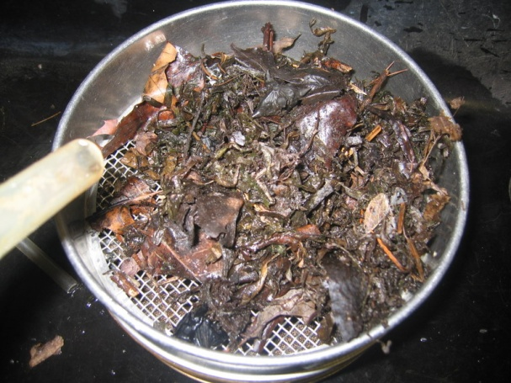
  - Have students place leaves in a tray of water and pick through tray to find the invertebrates.
- Have students sort the macroinvertebrates into Petri dishes using the identification sheets and keys. If student groups have more than one leaf pack type (AHS students) they need to sort and count each bag separately, one after another. You will need to introduce the term macroinvertebrates. If you think your students will take too long to sort the organisms from their whole pack, you can have students count a subsample of the pack or just sort for a set amount of time (e.g. 25 minutes). As they are sorting, prompt small groups to think about what they are doing: How many types of organisms are they finding? How can they tell when organisms are different kinds? How are the organisms different from one another? Do they think all of these organisms eat the same thing? Why or why not? Are all the organisms in a Petri dish the same? Prompt them to observe the organisms’ mouthparts, particularly to identify what “counts” as a “mouthpart.” One way to prompt small group discussion is to hand out discussion cards with one or more of the above questions on them to groups at various times throughout the class. You can also pass out the Macroinvertebrate Data Collection worksheet now if you want students to have the thought questions all at once but don’t have them record any data on the worksheet until they are done sorting. AHS groups will need two copies of the data collection worksheet.
- When they have sorted all of their organisms into the Petri dishes pass out the Macroinvertebrate Data Collection worksheet. Have students count the numbers of invertebrates in each Petri dish and record the data on the Macroinvertebrate Data Collection worksheet. For the 2 non-insect Petri dishes (e.g. with leeches and crayfish) have students count the major types of each invertebrate. They should also report the data so you can record it on a poster or the Excel worksheet by either turning in their worksheet or typing or writing the data themselves.
TEACHER’S NOTE - If you want to collect organisms one day and look at them the next, you can preserve the animals in a 70% ethanol solution, or you can keep alive. To keep the animals alive overnight, place them in a cooler or in the refrigerator with enough water; an air bubbler in the bucket will increase your chances that they will stay alive. If your students don’t have time to look at the organisms’ feeding structures (mouthparts) using hand lenses, dissecting scopes, or as a class with a video microscope on the sorting-counting day you can preserve at least a representative sample of each type of organism for identification of the mouthparts in the classroom for Lesson 4. If you have time at the stream, you can count how many of each type you have collected, and then keep one representative for classroom identification and analysis.
- Bring students together to talk about what they found. Add the list of organisms living in the stream from Lesson 1. As a class, discuss how many different kinds of organisms they found and how they were able to tell when there were different kinds. Emphasize careful observation of differences among organisms as a way of telling organisms apart. Have students share their speculation on whether they think these organisms all eat the same things and how they could explore that question if they wanted to.

Stream Characteristics Data Sheet
Date
 | Pool #1 | Riffle #1 | Pool #2 | Riffle #2
Water temperature

Dissolved Oxygen

pH

Stream Velocity

Other:

Stream Characteristics Physical Habitat Data Sheet
Measure a 10m segment of your stream to collect the following measurements:
Stream width:
Measure the stream at three different spots along your length and find an average: _________
Water appearance/odor:
___ clear ____ clear-brown _____ milky _____ greenish
___ foamy ____ muddy _____ multi-color _____ other (describe)
Stream velocity:
Step 1: Stream segment width
Find the average width of your stream segment at the top, middle, and bottom end of your segment.
Width top: _______
Width middle: ______
Width bottom: ______
Average: ______ m
Step 2: Stream segment velocity
Using your segment, drop a ping pong ball or a tennis ball (depending on the perceived velocity of your stream-a ping pong ball works better in slower moving water) and record the speed at which the object travels the length of the segment. You should do this at the left, middle, and right side of the stream, and then average your measurements.

Left side (sec) | Middle (sec) | Right side (sec) | Average
Average of all three segments (time in seconds)

Step 3: Stream depth. Stretch a tape measure across the stream at the mid-point of your stream segment. At 1 m intervals across the stream, measure the depth (in m) and record it in the table below. If you have a very wide stream, measure depth every 2 or 3m.
Distance (m) | Depth |  | Distance (m) | Depth
0 | 0 |  | 6
1 |  |  | 7
2 |  |  | 8
3 |  |  | 9
4 |  |  | 10
5 |  |  | 11

Sum of depths: ______ / number of samples taken = _________ average depth of stream

Step 4: Flow calculation
Now that you have all your measurements, simply plug in the numbers in the equation:

[10m (length) x _____ m (width) x _____ m (depth)] ÷ _____ (time secs) = _____ cubic meters/sec

Habitat:
 | Many | Some | Few/none
Riffles (fast areas, <2 feet deep)
Runs (fast areas, >2’ deep)
Pools (slow areas, >2’ deep)
Glides (slow areas, <2’deep)
Shelter for fish (logs, stumps etc)
Patches of aquatic plants

Substrate size: Rank the substrate sizes from most common (1) to least common (6)
Silt/clay/sand | Sand (0.06mm-2mm) | Gravel (2mm-64mm) | Cobbles (64mm-250mm) | Boulders (250mm-4000mm) | Bedrock (solid rock covering bottom)

Cobble Embeddedness: Pick up several cobbles (if present) to estimate the average embeddedness of your site.
Average embeddedness: _______ % 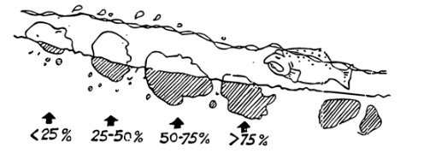
Image from Hudson Basin River Watch Guidance Document
Stream banks:
 | In no or few areas | In some areas | In many areas
Covered with vegetation
Eroding
Mowed
Artificially protected

Human Impacts and Land Use:
___ stream channel altered ___ farms ___ industry
___ storm drain pipes ___ recreation ___ housing
___ sewage treatment plant pipes ___ garbage ___ logging
___ dams ___ mining ___ roads

Other: ____________________________
For more in-depth survey guidelines, see Behar, S. and M. Cheo. 2004. “Hudson Basin River Watch Guidance Document.”
Macroinvertebrate Data Collection
Names in group: Place in stream (riffle or pool): Type of leaves: Stream Name: State:

- First, before you empty your bags out, observe how the litter looks (is it green, brown, decaying, in clumps, etc.). Carefully explore in and around the leaves. Do you see any organisms? Are any of them together? What parts of the leaf pack are the organisms in or on?
- Empty the bag of leaf litter according to your teacher’s instructions. Separate the animals you find into major groups using the key, sorting mat and Petri dishes provided.
- Now, count the numbers of invertebrates in each Petri dish on your sorting mat and record your data in the table on the next page. Take notes about relative sizes and any other things you noticed about the invertebrates in your leaf pack. Only fill out the Number and Notes columns today. You will keep this sheet and fill out the other columns later in this unit.
Example
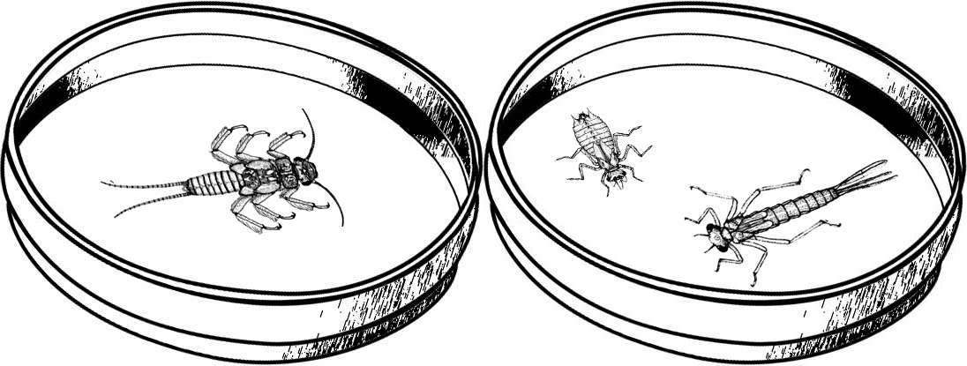
Major Groups  Common name (Order) | Number of individuals | Notes
Stoneflies (Order Plecoptera) | 1 | Seen eating a smaller invert
Dragonflies and Damselflies (Order Odonata) | 2 | Sizes: One big with skinny tail and one small with fat tail
Questions to think about while you are sorting your organisms:
How can you tell when organisms are different kinds?
How they look, how they act.
How are the organisms different from one another?
Number of legs, size, gills, shape, behavior, color…
Do you think all of these organisms eat the same thing? Why or why not?
It is unlikely all organisms eat exactly the same thing. If this were the case there would be intense competition, preventing the wide variety of diversity seen in the sample. Organisms feed on different things, or feed on the same thing at different times or at different locations.

Major Groups  Common name (Order) | Number of individuals | Notes | Kingdom | Phylum | Sub-  phylum | Feeding Group | Dissolved oxygen needs (mg/L)
Stoneflies (Order Plecoptera) |  |  | Animalia | Arthropoda | Hexapoda | Mostly Predators | 8-12
Dragonflies and Damselflies (Order Odonata) |  |  | Animalia | Arthropoda | Hexapoda | Predators | 4.1-7.9
Mayflies (Order Ephemeroptera) |  |  | Animalia | Arthropoda | Hexapoda | Mostly collectors | 8-12
Major Groups  Common name (Scientific classification) | Number of individuals | Notes | Kingdom | Phylum | Sub-  phylum | Feeding Group | Dissolved oxygen needs (mg/L)
Water Beetles (Order Coleoptera) |  |  | Animalia | Arthropoda | Hexapoda | Scrapers | 8-12
True Flies (Order Diptera) |  |  | Animalia | Arthropoda | Hexapoda | Collectors | >4
Crane Flies(Order Diptera, Family Tipulidae) |  |  | Animalia | Arthropoda | Hexapoda | shredders | 4.1-7.9
Dobsonflies and Alderflies (Order Megaloptera) |  |  | Animalia | Arthropoda | Hexapoda | Predators | 4.1-7.9
Caddisflies (Order Tricoptera) |  |  | Animalia | Arthropoda | Hexapoda | Shredders, predators | 8-12
Net-spinner Caddisflies (Order Tricoptera, Family Hydropsychidae) |  |  | Animalia | Arthropoda | Hexapoda | Collectors | 4.1-7.9
Water mites (Order Acari) |  |  | Animalia | Arthropoda | Hexapoda | Predators, collectors
Springtails (Subclass Collembola) |  |  | Animalia | Arthropoda | Hexapoda | Collectors, Shredders
Scuds (Order Amphipoda) |  |  | Animalia | Arthropoda | Crustacea | Shredders | 4.1-7.9
Sowbugs (Order Isopoda) |  |  | Animalia | Arthropoda | Crustacea | Collectors | 4.1-7.9
Crayfish (Order Decapoda) |  |  | Animalia | Arthropoda | Crustacea | Predators, collectors | 4.1-7.9
Snails (Class Gastropoda) |  |  | Animalia | Mollusca |  | Scrapers | >4
Clams and Mussels (Class Bivalvia) |  |  | Animalia | Mollusca |  | Collectors | 4.1-7.9
Leeches (Subclass Hirudinea) |  |  | Animalia | Annelida |  | Predators | >4
Aquatic Earthworms (Subclass Oligochaeta) |  |  | Animalia | Annelida |  | Collectors | >4
Planaria (Class Turbellaria) |  |  | Animalia | Platyhelminthes |  | Predators
Nematodes |  |  | Animalia | Nematoda |  | Predators

Lesson 3: Classifying: How are organisms related?

Explain 25 minutes

Instructional Goal
Students will know why and how we classify organisms by evolutionary relatedness, and be able to place organisms in a biological classification based on phylogeny. In lesson 4 students will learn another way to sort organisms, by a biotic requirement, feeding group, and abiotic requirement, dissolved oxygen level.

Materials
Organism cards, 14 macroinvertebrates cards only (1 set per pair of students) and magnets (or post-it notes)
Classification poster (1 per pair of students), this is made by taping the two 11” x 17” pieces of paper together
List of stream organisms from Lessons 1 and 2
Filled out copies of Macroinvertebrate Data Collection worksheet
Copies of How are organisms related? Worksheet
Computer or overhead projector to display Classification poster pdf

Advance Preparation
Remind students to bring or collect from students their filled out copies of the Macroinvertebrate Data Collection worksheet. Prepare overhead or download pdf of the classification poster. Cut out organism cards and tape the two halves of the classification posters together, if not done for you.

Lesson Procedure
- Start by projecting the classification poster and orientate students by having them name members of each kingdom: Animalia, Plantae, Fungi, Protista, Archaea, Bacteria. Students will probably not be familiar with Archaea so you will probably have to introduce them. You might want to do that now or in the second classification lesson which focuses more on microscopic life. It may be easier in that lesson to talk about how, even though Archaea and Bacteria look similar on the outside, they are very different with respect to their genes, what they eat, and other characteristics. Talking about how Archaea are often found in extreme environments is a good introduction.

TEACHER’S NOTE: The phylogeny depicted on this classification poster is drawn to make it an effective teaching tool while students are sorting organisms that are mostly animals. However, a phylogeny that represents the known diversity of life would be much different with animals taking up a small portion and bacteria the greatest amount of space. The figure on the next page is from adapted from a 2006 article in Science (go to http://www.bork.embl.de/tree_of_life/ for an interactive version). Blue represents the Domain Bacteria, green Domain Archaea, and Red Domain Eukaryota, which includes plants, animals, fungi, and protists.

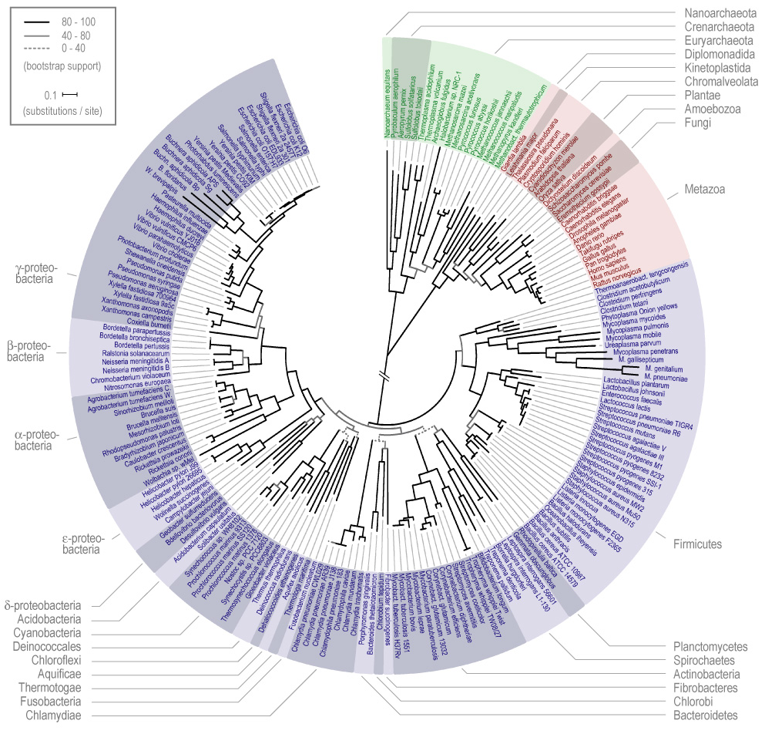
- Have students reform their groups. If some groups only found a few, 4 or so, types of organisms, many in the same Phyla, you may want to pool the classroom organism lists for each place (or leaf type) to come up with a list for students to use in this exercise. Alternatively, after they finish classifying the organisms they found in their pack, they can sort the rest of the 14 macroinvertebrate types. Students should use the pictures on the cards, their observations from Lesson 2 and information on the poster to classify (place in the appropriate spot on the poster) the macroinvertebrates on the classification poster.
- As they classify their organisms they should record the name of the Kingdom, Phylum, and Subphylum on the Macroinvertebrate Data Collection worksheet and answer the Data Analysis questions. You should decide how you will approach different levels of genetic similarity answers to questions 6-7, 9-10. You may want to discuss with advanced students the different levels of similarity (e.g. all organisms in an order are more closely related to one another than organisms in a kingdom, but all organisms in a order are no the same).
- You may want to use the projected poster and magnets (or post-it notes) to have a couple of students demonstrate how they classified their organisms.

- When they are finished, lead a discussion around the following questions: What does it mean to be related? Explain that groups arranged on the web in terms of their relatedness. Tell the students what the branching pattern means in terms of evolutionary relatedness. Here we want advanced students to recognize that DNA similarity is the primary relatedness characteristic, and thus evolutionary relatedness. We want all students to notice that some things about morphology (e.g. the way things look) is also similar between related individuals.
Why do we classify living things? Scientists classify living things in order to aid in studying the living world, including ecology and evolution. It makes it easier to study their properties (organisms with similar properties are grouped together). By knowing what group an organism belongs to, we automatically know some characteristics about that organism (e.g. if it is a dragonfly larvae, then it is a predator). The finer scale of classification (e.g., Kingdom v. Order) the more we know about the particular characteristics of an organism.
What kinds of characteristics would be good to use when classifying organisms? The most useful type of characteristic to classify an organism, is something that doesn’t change over time, with different conditions, or different life stages. The most commonly used type of characteristic in history has been morphology – the way things look, especially traits that don’t change. A better characteristic is DNA, because similar DNA sequences reflect a common and recent evolutionary ancestor and DNA sequence doesn’t change with time or environmental conditions. Students might also talk about the other ways to classify organisms including how they interact with other organisms (e.g. position in a food web) and behavioral characteristics. Question 12 is an introduction to this and Lesson 4 will begin to explore these functional classifications.
How are organisms related?

Use the group names and characteristics on the Classification Poster to classify the macroinvertebrates you found in your leaf pack. Put each card in the appropriate box. Record the name of the Kingdom, Phylum, and subgroup on your Macroinvertebrate Data Collection worksheet.

Data Analysis
- How many different Orders of organisms did you find in your pack? Varies
Are all of the organisms in each Order exactly the same? NO

- In what ways are organisms in an order the same?
They are all in the same kingdom: Animalia, all probably invertebrates, they have similar body structures (e.g. exoskeletons, muscles, number of legs, gills or no gills), all are found in leaf packs, often in the same feeding group, are genetically related.
- In what ways are organisms in an order different?
The body structures aren’t exactly the same (e.g., some have bigger gills than others, some are different colors or sizes), some of them are in different feeding groups or trophic levels, are different genetically.
- How many different Phyla of organisms did you find in your pack? Varies depending on leaf pack, but probably less than orders
- In what ways are organisms in a Phylum the same?
They are all in the same kingdom: Animalia, all probably invertebrates, all are found in leaf packs, all have similar body plans but not as similar as those within the same order (e.g. exoskeletons but not the same number of legs, inverts but not all with exoskeletons, some shells or no covering).
- In what ways are organisms in a Phylum different?
The body structures aren’t exactly the same (e.g. exoskeletons but not the same number of legs, inverts but not all with exoskeletons, some shells or no covering)., some of them are in different feeding groups or trophic levels, are different genetically.
- How many different Kingdoms of organisms did you find in your pack?
Probably 2 macroscopically IDed Kingdoms: Animalia and Plantae. Students might not mention plants here and you will have to bring it up.
- In what ways are organisms in these Kingdoms different from one another?
Animals are mostly mobile and have to eat their food. Plants are mostly sessile and make their own food using inorganic/nonliving material.

Lesson 4: Classifying: Who eats whom?

Explain 45 minutes
Optional 25 minutes

Instructional Goal
Students will know that organisms have specific biotic requirements (in this case food typeswhich can only be eaten by specific functional feeding groups) and abiotic requirements (in this case, differing amounts of dissolved oxygen which are required by different orders). Students will know how functional feeding groups of macroinvertebrates in fresh water ecosystems (i.e. predators and other consumers: scrapers, shredders, and collectors) get food and how the feeding activities of these organisms change characteristics of their abiotic environment (i.e. water clarity, dissolved oxygen, and minerals). Students will know that producers (mainly terrestrial trees until Lesson 9 when they observe microscopic algae) provide the matter and energy for the ecosystem, and will be able to create an incomplete food web of a local aquatic ecosystem. Students will know that multiple types of organisms can be in each feeding group type.

Materials
Organism cards, 14 macroinvertebrates cards only (1 set per pair of students) and magnets (or post it notes)
Food Web Lesson 4 template (1 per pair of students, optional)
List of stream organisms from Lessons 1 and 2
Filled out copies of Macroinvertebrate Data Collection worksheet
Copies of Stream Biology Briefs Reading
Computer or overhead projector to display Food Web poster pdf and Functional Feeding Group ppt and videos.

Advance Preparation
Remind students to bring or collect from students their filled out copies of the Macroinvertebrate Data Collection worksheet. Make copies of Stream Biology Briefs and the Food Web poster. Prepare overhead or download pdf of the Food Web poster. Prepare overhead printouts or download the Functional Feeding Group ppt presentation. There will be links in the PPT to videos of feeding. Make sure the links work properly on your computer.

Lesson Procedure
- If you did not have time for students to observe the mouthparts of the macroinvertebrates in Lesson 3, you may want to begin the lesson by allowing them to observe your preserved specimens using dissecting scopes or hand lenses. If you have a video microscope you can review the mouthparts as a class. Reviewing mouthparts will cause this lesson to be an optional extra 10-15 minutes.
Show the Functional Feeding Group PowerPoint and discuss how we can classify different organisms by their different feeding requirements. In this case, what kind of organisms or organic material they need for food (see answer to question 8 for review). Present each major feeding group by showing the example pictures and videos and discussing how they feed. You should also discuss how different shaped mouthparts make different organisms suited to eat different things in different ways, i.e. shredding, scraping and collecting. Competition for food by organisms of the same feeding type is a biotic interaction students should recognize and discuss here. There are notes in the PowerPoint to help in discussion.
- Now remind students about how different organisms also have different abiotic resource and condition requirements. In this case we will focus on requirements for dissolved oxygen. Review dissolved oxygen; you may want to use the lesson suggested during lesson 1.
- After the presentation, depending on the independent working ability of your students, have students use the Stream Biology Briefs reading to classify each type of organism in their pack (or in all the packs from where their pack was located: riffles or pool—whichever way works best for you) according to feeding group. If students would struggle with the reading you may choose to read through the briefs as a class. Not aloud, but go around the classroom asking students to silently read an organism description and tell what that groups’ feeding group and dissolved oxygen requirements are.
- Now students should construct a food web of the stream community on an 11 x 17 piece of paper (8.5x 11 if each student is making their own. You or your students should keep these to use in Lesson 8). Many students are overwhelmed by building a food web if there are multiple groups of organisms in each feeding type (e.g. three orders of collectors, 2 predators etc.) or because they are not familiar with decomposers and have a hard time building a food web using just the filled out Macroinvertebrate Data Collection table. You may want to guide students to group the types of organisms by feeding type in their food web or scaffold their food web construction by providing a copy of the Food Web Lesson 4 template. Students can then use this model food web and their organism list or cards to construct a food web. They should draw the arrows to indicate matter-energy transfer themselves. Their web may still be incomplete as students might not add all producers or decomposers or vertebrates. These extensions will be added in Lesson 8.
For AHS groups with two packs, you should have them either make two food webs or have half the class use their deciduous packs and have the coniferous.
- When they are finished with their food web students should then answer the questions on the Who eats whom? Worksheet. When they are done, build a food web on the board (using the food web poster if needed) using the magnets (or post-it notes) and lead a class discussion on why organisms need food (i.e. matter for growth and reproduction and energy for life’s processes) and where the different feeding groups of macroinvertebrates (i.e. predators and other consumers: scrapers, shredders, and collectors) get their food (i.e. each other, decomposers, and producers).
- Now have student think about how the feeding actions of each group (e.g. removing prey organisms from the environment or breaking down organic material into smaller pieces) would affect abiotic factors in the stream. As a class, fill out the chart describing these changes. The key is to think about what the food does when it is in the environment and then to speculate on what would happen when it is gone or broken down.
- Ask students why there might be more than one organism type in each feeding group (just assess your students’ understanding for now, this topic will be explored in greater depth in Lesson 10).
- You might choose to have students switch their food web with another group. The groups should point out 2 aspects of the food web that they really like and 2 aspects that could be improved. We have found sharing food webs to be a great learning experience but it will add at least an optional 10 minutes to this lesson.
Who eats whom?
- Why do organisms eat?
To provide cells with the matter for growth and reproduction and energy for life’s processes.

- What do each of the following types of organisms eat?
  - Predators:
Other animals, they may be from one or a variety of trophic levels.

  - Scrapers:
Algae, bacteria, and fungi which they scrape off hard surfaces such as rocks

  - Shredders:
Algae, bacteria, and fungi which they remove from leaves as they break them into smaller pieces
  - Collectors:
Fine pieces of organic matter

- Do all organisms in a feeding group have the same dissolved oxygen requirements?
No

- Check your food web diagram. Did you diagram the way each of the organisms in your food web gets their food? Arrows should show the direction matter and energy is moving (e.g., from producer to consumer). Students often use arrows pointing in the other direction to indicate feeding relationships and not matter and energy flow.

- In which type of feeding group did you find the greatest number of organisms?
Why do you think that is?
Generally, students should say because there might have been more food there (a biotic interaction reason) or it might have been the right abiotic environment (e.g. dissolved oxygen levels) for more of those organisms.
Why predators – there may have been an abundance of prey that they were drawn to
Why scrapers – the leaf pack contained or sat on hard surfaces that scrapers feed on
Why shredders – leaves where they feed broke down easily
Why collectors – may have been secure place to sit and collect from the water or leaf material broken down may provide food

- Are there any feeding groups described in the Stream Invertebrate Biology Briefs that you did not find in your sample? Why do you think that might be?
They were not present in that portion of the stream, or at the time of collection. Their food source was not present in the bag. We didn’t use tools to observe them (microscopes etc.).

- Pick one group of organisms that you found in the stream (ex: mayflies):
What feeding group is your group in?
Use your food web drawing to predict what you think would happen to the other organisms found in the leaf pack if your chosen group of organisms did not exist in the stream? Depends on what they choose, but answers should be drawn from relationships in the food webs students draw.
- Competitors of that organism might be present in larger numbers.
- Prey for the predator of the organism chosen may be stressed by increased predation and present in lower numbers.
- Predators of that organism would need to find another food source.
- Organisms that depend on the chosen organism for resources would suffer (for example absent shredders mean less food for some organisms, absent predators may mean that theprey of the chosen organism would not be controlled and would potentially overconsume its food source

- Complete the table below. Hint: The key is to think about what the food does when it is in the environment.
Feeding Group | What organism does this group eat? How does it get its food? | How will a decrease in that food affect the abiotic environment?
Scrapers | Algae. They scrape the algae off of surfaces. | Algae are producers that make their own food using photosynthesis. Producers release oxygen when they make food. A decrease in algae will lead to a decrease in oxygen in the water.
Collectors | Bits of organic matter and small organisms floating in the water. They take the floating bits out of the water. | Bits of organic matter and small organisms floating in the water make the water cloudy turbid). A decrease in the bits in the water will lead to the water being clearer. This will let more sunlight into the water.
Shredders | Bacteria and fungi on leaf surfaces. They tear up leaves into small pieces. | Shredders tear up leaves into small pieces. This leads to an increase in sunlight. For example, in wetland ecosystems where this does not occur quickly, leaves pile up and hinder light availability.  If your students are already familiar with decomposition you can add: Bacteria that bacteria and fungi are decomposers. Decomposers are messy eaters that leave a lot of nutrients in the water. A decrease in bacteria and fungi will decrease the amount of nutrients in the water

Lesson 5: Identifying: What lives in leaf packs? Let’s look closer

Elaborate: Explore 30-50 minutes

Instructional Goal
Students will know how to observe characteristics of microscopic organisms in an aquatic ecosystem, recognize that a diversity of microscopic life exists, and be able to group these organisms based on similarities and differences in morphology. Students will know that decomposers, bacteria and fungi, have specific biotic requirements (easily or less easily digestable organic matter) and abiotic requirements (different bacteria and fungi require difference amounts of dissolved oxygen).

Materials
Filled out copies Macroinvertebrate Data Collection worksheet
Stream organism poster from Lessons 1 and 2
Decomposer PowerPoint presentation and projector to display it
At least one of the following is required:
- “Life in a Drop of Water” full video at: http://www.unitedstreaming.com if you have a subscription or clips free at: http://videos.howstuffworks.com/search.php?media=video&terms=life+in+a+drop+of+water
- Computer classroom, have students explore “The smallest page on the web” http://www.microscopy-uk.org.uk/mag/wimsmall/smal3.html
- Video compound microscope
Copies of Life in a Drop of Water key
- Compound microscopes (1 per pair or small group of students)
Slides (regular or depression) and cover slips
Pipettes
Water samples from stream with one ortwo leaves in each jar sample (one or two per leaf type) to feed microbes.
Demoslides
Alcohol or Protoslo to slow down microbial movement
Copies of Life in a Drop of Water key

Advance Preparation
Remind students to bring, or collect from students, their filled out copies of the Macroinvertebrate Data Collection worksheet. Make copies of Life in a Drop of Water key (Appendix B, get a copy from your research contact). Download Decomposers ppt presentation. If you are using microscopes of any kind you will need to save water samples from Lesson 3; store samples with one or two leaves in each jar sample (one jar or two jars per leaf type) and prepare materials for students.

Lesson Procedure
- Start by asking students what type of organism was missing from the food web they constructed in Lesson 5. Tell them today they will be taking a closer look at some other organisms that lived in their leaf packs.
- Using the video scope or individual microscopes (you can use the “Life in a Drop of Water” video or “The smallest page on the web” if you don’t have microscopes available) have students observe and identify, using the Life in a Drop of Water key, different types of microorganisms found in their leaf packs. Record the organisms the class observes by updating the classroom list. Students will not be using this data in a quantitative way so there is no need to count organisms or be very precise in identification. The goal here is for students to understand there is a huge diversity of life they cannot see.
If you don’t have a video scope you may consider showing a few minutes of “Life in a Drop of Water” to give students an idea what to look for when they are using microscopes themselves. If you have time you can discuss the feeding roles of the various organisms (Small arthropods and other protists are mostly consumers (omnivores) that eat small arthropods, protists, bits of detritus, algae etc.; Protists with chloroplasts (euglena, algae) are producers.) If not, you can do this in Lesson 6.
Having students create their own slides and investigate microscopic organisms using individual microscopes will increase the length of this lesson by at least 20 minutes. You will need to instruct them on how to make a wet mount slide and decide the best practices for searching for microbes on wet mount slide.
WET MOUNT INSTRUCTIONS: Place a few drops of river water on a slide and put a cover slip on top. If possible, include some decaying leaves or bits of plant matter, as they will prevent the small organisms from being squashed. Look at the slide under your microscope starting at low power. Look near the decaying leaves of the water plants, and try to find living organisms -- if the protists or small animals are moving they probably are alive.
After observing the organisms swimming around in the water, you may want to use Protoslo or a drop of alcohol to slow down the protists so that you can see them better. Put one tiny drop of Protoslo on a clean slide. Then, place a drop of pond water on top of the Protoslo and mix gently with a toothpick. Place a cover slip over the solution. Examine the slide under low power first to find moving objects. Then, increase to medium and high power. Try to find a protist moving very slowly and describe how it moves.
- After students are done observing with microscopes or watching the video tell them you are going to show them pictures taken with an even stronger microscope so they can see even smaller organisms that live on leaves in the water. Show the Decomposer ppt presentation and discuss the role of these organisms in decomposing leaves. There are notes in the notes section of the ppt to help guide discussion. Update the organism list started in Lesson 1 with these microscopic organisms. It would probably be good to talk about numbers of individuals here. For example, a gram of soil can contain a billion or more bacterial cells. It probably doesn’t matter what large number you use, because it should be obvious how many more that is compared to what they found for macroscopic organisms. If you don’t have time here, you might choose only to show the Decomposer ppt and then move the discussion around decomposers in Lesson 6, when students classify fungi and bacteria on the classification chart.
The big take-home messages with respect to microorganisms are these:
- Microorganisms are everywhere and they are present in numbers so large we can’t even comprehend them.
- Bacteria and fungi are evolutionarily and morphologically different, but perform many of the same metabolic functions. They are the true decomposers—they release nutrients and carbon back into the environment from dead organic material, so that other organisms can use those compounds again (e.g. plants).
Students can usually name “bacteria” and “fungi” as examples of microorganisms. It is important to stress that there are many more “good” or harmless bacteria than there are “bad” or pathogenic ones. You may also want to highlight the major differences between bacteria and fungi. Bacteria are in their own domain of life, whereas fungi are in the same domain we are—Eukarya. Thus, humans are more closely related to fungi than they are to bacteria. Bacteria are single-celled organisms, whereas fungi are multicellular. Bacteria do not have a nucleus in their cells, but fungi do. What they do have in common is that their genetic information is contained and transferred in DNA.
Our motivation for discussion of microorganisms in Lessons 5-7 is that students typically do not recognize (1) the existence of microorganisms (both decomposers and other microscopic organisms) and (2) the role those organisms, decomposers in particular, play in ecosystems. In our experience, students think that organisms like earthworms and insects are decomposers. In fact, the majority of true decomposition (i.e. the conversion of dead organic material back into inorganic components like CO₂ and ammonium/nitrate) is performed by bacteria and fungi. The way in which bacteria and fungi accomplish this task is different from animal metabolism—we have our digestive enzymes inside us, whereas these microorganisms excrete their enzymes into the environment. Once the enzymes are out in the environment, they act on the detritus, releasing smaller, soluble organic molecules that these microorganisms can transport into their cells, where they (like us) use those compounds for energy (through cellular respiration) and to build biomass. Cellular respiration results in CO₂ production, completing the carbon cycle and putting the C from detritus back into the atmosphere where plants can use it for photosynthesis.
When it comes to nutrients like nitrogen, it is sufficient to think of decomposers as “messy eaters.” In some cases, the compounds released by the enzymes don’t get back to the bacteria or fungi that made the enzymes, and instead can get taken up by other organisms, like plants or photosynthetic protists. However, plants and algae (generally, there are exceptions) can’t take up organic compounds from soil or water, so it is safe to say that most organic molecules are going to be processed by a bacterium or fungus sometime during decomposition.
So, why do bacteria and fungi release nitrogen into the environment instead of having evolved a more efficient feeding mechanism that will not “waste it”? Microorganisms need carbon and nitrogen in particular ratios (typically about 20:1); if the compounds they are eating differ from that ratio, they can either release excess N (because they don’t have enough C to go with it; called mineralization) or compete with plants for N in the environment (because they don’t have enough N to go with their C; called immobilization). Some microorganisms can use nitrogen compounds instead of oxygen for cellular respiration (called denitrification), which converts the N back into a gaseous form that goes back into the atmosphere, completing the N cycle).
This may be more complicated than you want for your students. For most students, it is probably a good step forward that they understand that bacteria and fungi are responsible for decomposition and that these processes are chemical in nature and take place outside the cell. However, like all other broad groups of organisms, there are differences in “food preference” between bacteria and fungi. Generally, bacteria prefer easier-to-degrade compounds like sugars whereas fungi are better at decomposing complex compounds like wood. You may want to push your students to extend some of their conclusions about “different organisms have different biotic and abiotic requirements” to bacteria and fungi.
There are several challenges with teaching students about microorganisms and decomposition. (1) In their natural environment (in water, on leaf surfaces or in soil), microorganisms are not visible even with most school laboratory microscopes. Environmental scanning electron microscopes can take good, still pictures of microorganisms, but they still aren’t very dynamic. One exception is white rot fungi, which you can grow by keeping some straw or wood moist in a jar with some soil (and maybe a bit of nitrogen fertilizer). (2) For the most part, microbial ecologists study microorganisms indirectly (i.e. we never look at them)—we extract DNA, we measure their activity (e.g. CO₂ or N₂O production) or we measure their ability to metabolize a compound by measuring how much of the compound disappears over time. There are lots of interesting ways to look at microbial activity, but they all require understanding indirect measurements and what they mean (difficult for students). (3) It is practically impossible to generalize about microorganisms. There are microorganisms that can do just about every kind of metabolism, and not just in extreme foreign places like hydrothermal vents. ENERGY: In an aquatic ecosystem, there will be some organisms that get their energy from carbon compounds (like us), and others that get their energy from nitrogen compounds (nitrifying bacteria convert ammonium to nitrate to capture energy). MATTER: Some will get their carbon from organic compounds (like us) and others will get their carbon from CO₂. As we mentioned earlier, there are many microorganisms that can use compounds other than oxygen as electron acceptors in respiration—some use nitrate whereas others can even use CO₂ (methanogens). Thus, you can see that microorganisms are a huge (and interesting) topic all on their own.

Lesson 6: Classifying: How are organisms related? Revisited

Elaborate: Explain 25 minutes

Instructional Goal
Students will know how we classify organisms by evolutionary relatedness, and be able to place organisms in a biological classification based on phylogeny.
Materials
Organism cards, all (1 set per pair of students), and magnets
Classification poster (1 per pair of students)
Filled out copies Macroinvertebrate Data Collection worksheet
Copies of How are organisms related? Revisited
Computer or overhead projector to display Classification poster pdf
Advance Preparation
Remind students to bring, or collect from students, their filled out copies of the Macroinvertebrate Data Collection worksheet. Prepare overhead or download pdf of the classification poster. Cut out organism cards and tape the two halves of the classification posters together if you didn’t do Lesson 3.
Lesson Procedure
- Have students review all of the microorganisms in their packs by looking at the classroom list. Now challenge them to add parts of the broader community that they didn’t sample, but think are in the stream, to the list.
- Project the Classification Poster and re-orientate the students. If you have time, have a couple students come to the board and using the projected poster and magnets classify the organisms from Lesson 3.
- Students should now classify the microscopic and other organism cards (which describe organisms similar to the ones they should have found in Lesson 5 and macroscopic organisms found in or around a stream but not in the leaf pack). Again, they will use the information on the sorting cards and classification poster. As they classify their organisms they should answer the questions on the How are things related? Revisited Worksheet. Make sure to discuss decomposers and show the Decomposer ppt if you did not do so in Lesson 5.
- Use the projected poster and magnets to have a couple of students demonstrate how they classified their organisms. Have the students discuss any differences in their classification methods.
Review the handout with the students and revisit the discussion questions from Lesson 3, especially why we classify organisms. Since students are now familiar with a larger diversity of kingdoms they should more readily understand that an organism’s classification can tell us something about their characteristics (e.g. all plants are producers, fungi are all consumers): What does it mean to be related? Here we want advanced students to recognize that DNA similarity is the primary relatedness characteristic, and thus evolutionary relatedness. We want all students to notice that morphology (e.g. the way things look), ecology and trophic level may also be similar between related individuals, but not necessarily. Why do we classify living things? Answers may vary here depending on student opinion. Scientists classify living things in order to aid in studying the living world, including the ecology and evolution of living organisms. By knowing what group an organism belongs to, we automatically know some characteristics about that organism. The finer the scale of classification (e.g., order is at a finer scale than kingdom) the more we know about the particular characteristics of an organism. What kinds of characteristics would be good to use when classifying organisms? The best type of characteristic to classify an organism, is something that doesn’t change over time, in different conditions, or different life stages. The most commonly used type of characteristic in history has been morphology – the way things look, especially traits that don’t change. A better characteristic is DNA, because similar DNA sequences reflect a common and recent evolutionary ancestor and DNA sequence doesn’t change with time or environmental conditions. Students might also talk about the other ways to classify organisms including how they interact with other organisms (e.g. position in a food web). Refer back to Lesson 4 to discuss functional classifications—feeding group.
How are organisms related? Revisited

- Using the classification poster and organism cards, classify the microscopic organisms. Are all microscopic organisms in the same Kingdom? No

- Classify the parts of the community that you didn’t sample because they were outside your leaf pack, but still impact the community in your leaf pack. Why do you think they were not in the leaf pack?
Answers may include ideas about dispersal (couldn’t get to the leaf pack because the holes in the bag were too small), abiotic resources and conditions (e.g. they need more oxygen than the water in between leaves) or biotic resources and constraints (e.g. not enough food not available only in leaf pack). Answers might also include a time component: the organisms may have been there if we looked at a different time.

- Why do you think those things impact your leaf pack community even though you didn’t see them?
Answers could include ideas about producers which are the basis of the food chain, predators that eat organisms but aren’t found in the leaf pack, decomposers that make nutrients available, competitors that deplete resources, plants that make the stream shady.

- How many different Kingdoms of organisms are interacting in this stream ecosystem (including the ones you did not sample)? Probably all six kingdoms are present in the stream or impacting the stream though students could probably group bacteria and Achaea together.

- In what ways are these kingdoms the same? All organisms make their home in or near the stream, and all are living organisms (e.g. have DNA, made up of cells and molecules, reproduce, need food).

- In what ways are these kingdoms different?
There are many differences between kingdoms – genetic, morphological, producers vs. consumers vs. decomposers, phenological (present at different times of year), prokaryote vs. eukaryote…. And other differences.

Lesson 7: Optional—Classifying: What size is it?

Elaborate: Explain 20-25 minutes

Instructional Goal
Students will know the relative sizes of microscopic and macroscopic organisms identified in the leaf pack, and be able to describe the relative size and composition of matter and organisms found in a stream environment: is it made of atoms and/or molecules and/or a single cell and/or multiple cells.

Materials
Organism, inorganic, and organic cards, all (1 set per pair of students), and magnets
Small Powers of Ten poster (1 per pair of students)
Copies of What size is it? Worksheet
Computer or overhead projector to display Powers of Ten poster pdf

Advance Preparation
Prepare overhead or download pdf of the Powers of Ten poster. Partial key: water molecule 10⁻⁹, dissolved inorganic matter like nitrogen, phosphorus and dissolved oxygen 10⁻⁹, algae 10⁻⁵ to 10⁻⁴, fish 10⁰, oak trees 10¹…

Lesson Procedure
- Begin the lesson by orientating students to the Powers of Ten poster by sorting familiar objects—pencil, eraser, dog, car etc.
- Pass out the What size is it? Worksheet and have students use it to determine the size of all the organisms they have identified in their leaf packs plus the extra things (larger organisms, organic and inorganic matter) using the organism and other cards. List the cards you want them to sort on the board.
- After they determine the size of the items they should fill out the rest of the chart: is the thing living or non-living, what is their reasoning (e.g. Can it reproduce? Can it find or make its own food?), is the item made of atoms and/or molecules and/or a single cell and/or multiple cells?
- When students are done with the chart, use the projected poster and magnets to have a couple of students demonstrate how they classified their cards. Have the students discuss any differences in their classification methods. Be sure to draw students’ attention to how small bacteria and fungi are and review the consequences that being small has on how they eat (i.e. external digestion, which leads to them leaving mineral nutrients in water—or soil).
- If students understand elements, and you want to tell them where you can find certain elements inside living single and multi-celled organisms, the following is a good start:
- Nitrogen atoms are commonly found in proteins and DNA.
- Phosphorus is found in DNA.
- Oxygen is necessary inside all living organisms to get energy from food through the process of cellular respiration and is part of the chemical formula of carbohydrates, proteins, fats and DNA.
- Carbon is part of the chemical formula of carbohydrates, proteins, fats and DNA.
- Hydrogen is part of the chemical formula of carbohydrates, proteins, fats, and DNA.
What size is it?
Using your Macroinvertebrate Data Collection worksheet copy the names of some of the organisms you identified in your leaf pack. Using the Powers of Ten chart and the Organism Cards, decide what size each of these organisms are. Then record the size in the chart below and decide if each item is living or non-living, and what each thing is made of.

Name of Organism |  | Size |  |  | Is it Living or  Non-living? |  | What is it made of?  atoms and/or  molecules and/or  a single cell and/or  multiple cells
Microorganisms
1
2
3
4
5
6
Macroinvertebrates
1
2
3
4
5
6
7
8
9
Other organisms
1
2
3
4
Matter in water
Nitrogen molecules
Phosphorus molecules
Oxygen molecules
Organic matter
Water molecules

- What is a mature Oak tree made of? Start with the visual parts of the tree that you can see and finish with the smallest particles you can trace. E.g. leaf, leaf cells, organelles-chloroplasts, nucleus, molecules-carbs, fats, atoms-CHNO

- Is there Carbon in an Oak tree? Nitrogen? Oxygen? Phosphorus? How do we know?

Lesson 8: Classifying: Who eats whom? Revisited

Elaborate: Explain and Elaborate 35-50 minutes

Instructional Goal
Students will know the major feeding group types of microscopic organisms and larger organisms (i.e. producers, consumers-predators and other consumers: shredders, collectors, scrapers, decomposers) in fresh water stream ecosystems. Students will know how the feeding activities of producers, decomposers, shredders, collectors, and scrapers influence the stream’s abiotic environment (i.e. water clarity, dissolved oxygen, and minerals) and will be able to predict how a change in the population of each would impact the stream’s abiotic environment and in turn the biota in the stream. Students will be able to create a more complete food web of a local aquatic ecosystem. Students will know that multiple types of organisms can be in each feeding group type.

Materials
Organism cards, (1 set per pair of students, optional) and magnets
Who eats whom? Revisited worksheet (1 per student)
Food Web Lesson 8 tempate (1 per pair of students, optional)
Filled out copies of Macroinvertebrate Data Collection worksheet
Stream ecosystem food webs from Lesson 4
Copies of Stream Biology Briefs Reading
Computer or overhead projector to display Food Web poster pdf

Advance Preparation
Remind students to bring or collect from students their filled out copies of the Macroinvertebrate Data Collection worksheet and Stream ecosystem food webs from Lesson 4; they might also need their Stream Biology Briefs. Make copies of Food Web Lesson 8 template, if needed, and Who eats whom? Revisited worksheet. You might consider decreasing or increasing the number of filled out boxes in the table on the worksheet if your students need less or more support. Prepare overhead or download pdf of the Food Web poster.

Lesson Procedure
- Have students refamiliarize themselves with the stream food web they diagramed in Lesson 4 and then add to their food web other organisms they didn’t have on before (both microorganisms and the larger organisms that live in a stream but weren’t found in the pack). Again, some students, especially young or inexperienced students, may have a hard time building a food web and you may want to scaffold their food web construction by providing a copy of the Food Web Lesson 8 template.
- As students are working, be sure they have identified specific kinds of decomposers (bacteria and fungi) and producers (trees that live on the river bank and drop their leaves, algae) rather than simply “decomposers” or “producers”. Students may especially need some help determining what protists and other microorganisms eat (as producers, consumers, collectors, or decomposers—see the food web diagram below). Advanced students might want to add a step between collectors and leaves: particulate or dissolved organic matter.
- Have students answer questions 1 and 2 on the Who eats whom? revisited Worksheet
- Lead a class discussion on why organisms need food (i.e. matter for growth and reproduction and energy for life’s processes), where major feeding group types of microscopic organisms and larger organisms (i.e. producers, decomposers, consumers-predators and other consumers) get their food, and why there might be more than one organism type in each feeding group (again just assess your students’ understanding for now, but pushing a little harder, this topic will be explored in greater depth in Lesson 10). Students should also discuss the potential implications of multiple organisms of each feeding type: competition for resources.
- Now have students fill out the chart and answer the accompanying questions (3+). This chart is designed to get students to think about how organisms change their environment by feeding and the subsequent consequences on the rest of the community. You might consider decreasing or increasing the number of filled out boxes in the table on the worksheet if your students need less or more support. You will also discuss functional redundancy (question 5).
- Lead a class discussion on the chart and questions. You may find it helpful to use the figure below (a model stream ecosystem food web and a microscopic food web) or a simplified one you construct with the Food web poster and magnets to lead students through how changes in the biotic environment can change the abiotic and biotic environments. It is not expected that all students will be able to produce these food webs.
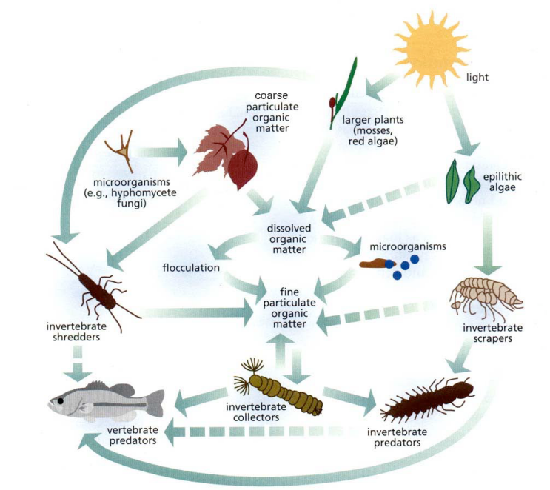
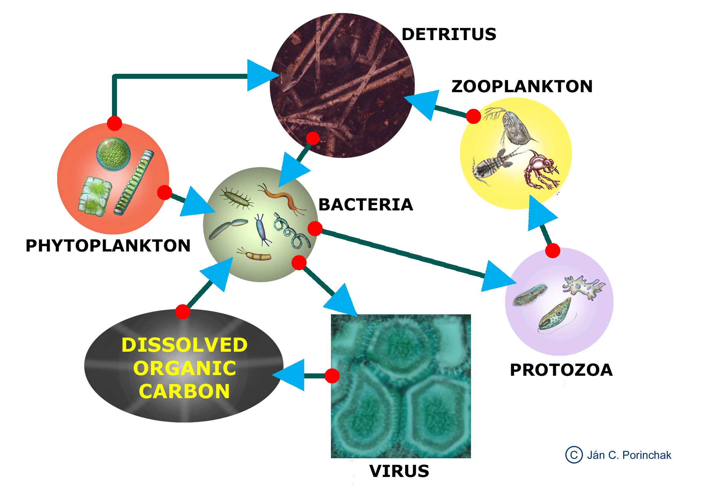
Who eats whom? Revisited
- How do each of the following types of organisms get food?
  - Producers:

  - Decomposers:

  - Consumers:

Check your diagram. Did you diagram the way each of the organisms in your food web gets their food?

- Is there more than one type of microscopic consumer in your pack?

Why do you think that is? Why is there not just one best type of microscopic consumer?

- Complete the table below. Hint: The key is to think about what the food does when it is in the environment.
Feeding Group | What organism does this group eat? How does it get its food? | How will a decrease in that food affect the abiotic environment? | What organism groups can be affected by this abiotic factor? | How will the change in the abiotic factor affect this group?
Decomposers | Dead organisms. | Bacteria and fungi are decomposers. Decomposers are messy eaters that leave a lot of mineral nutrients in the water. A decrease in bacteria and fungi will decrease the amount of mineral nutrients in the water. | Producers | Producers need mineral nutrients so they might grow slower if there are less mineral nutrients in the water.
Scrapers | Algae. They scrape the algae off of surfaces. | Algae are producers that make their own food using photosynthesis. Producers release oxygen when they make food. A decrease in algae will lead to a decrease in oxygen in the water. | Any organism that has specific oxygen requirements. | It depends on how much oxygen they need.
Collectors | Bits of organic matter and small organisms floating in the water. They take the floating bits out of the water. | Bits of organic matter and small organisms floating in the water make the water cloudy. A decrease in the bits in the water will lead to the water being clearer. This will let more sunlight into the water. | Producers. | An increase in sunlight will let producers make more food.
Shredders | Bacteria and fungi on leaf surfaces. They tear up leaves into small pieces. | Shredders tear up leaves into small pieces. This leads to an increase in sunlight. For example, in wetland ecosystems where this does not occur quickly, leaves pile up and hinder light availability.  Bacteria and fungi are decomposers. Decomposers are messy eaters that leave a lot of nutrients in the water. A decrease in bacteria and fungi will decrease the amount of nutrients in the water | Producers. | Sunlight would decrease because the leaves aren’t being broken down and decomposed. Producers need sunlight so they will do worse with less sunlight
Producers | Makes their own food using sunlight, CO₂ and water and produce O₂ and food. | When producers make food they increase the amount of oxygen in the water. | Any organism that has specific oxygen requirements. | It depends on how much oxygen they need.
- What would happen to the abiotic environment if collectors disappeared from the stream?
The water would get cloudier and less sunlight would get into the water.

- What would happen to the biotic environment if collectors disappeared from the stream?
There would probably be fewer algae and more of the little organisms collectors eat.

- What would happen to the abiotic and biotic environment if there were three types of collectors and one of them disappeared from the stream?
It depends on if the other two types of collectors can live all the places the one that disappeared lived. If they can live in the same habitats (e.g. if they can live in with the same oxygen amounts) than those two types would become more abundant and there may not be changes in the abiotic environment. If they cannot live in the same habitats, than there might be an increase in the cloudiness in those habitats.

- You have just learned how an organism can change its abiotic environment in a way that also affects the other members of biological community. Can you think of any changes to a biological community in another ecosystem that would change the abiotic environment and therefore affect the biological community?

Various answers that are parallel to the stream (e.g. decomposers do the same thing in the forest as the stream). Another example: Trees create shady (and cool) environments underneath them by absorbing the sunlight. If there are a lot of deer (eating saplings) or humans cutting down trees the sunlight reaching the ground might increase. This will let small plants (e.g. shrubs or grasses) that need a lot of sunlight grow more. It might also change the animal community by restricting those animals that need a temperature.

Lesson 9: Comparing the stream to what is familiar

Evaluate 20 minutes

Instructional Goal
Students’ knowledge will be assessed regarding Lessons 1-8 by asking students to summarize their findings in the context of a different system – the one they originally described in Lesson 1. This unit has been designed to help students uncover the major factors that structure biological communities: Organisms have particular abiotic (e.g. the concentration dissolved oxygen, the amount of sunlight) and biotic requirements (e.g. type of prey or food available) that must be met if they are to survive and reproduce.
Although they’ve examined these requirements in detail for the stream community using their leaf packs, they should now be able to apply these ideas to any ecosystem, even those for which they don’t know all of the details. One key conceptual link for students to make between the streams and the (likely) terrestrial ecosystems that they originally described is in the way that new energy is introduced into the system. For most ecosystems, solar energy captured during photosynthesis and stored as chemical energy in producers is the energy source for all of the other organisms ‘higher’ in the food web. In an ecosystem built on decomposition, such as the leaf packs, the fresh inputs of energy are in the form of chemical energy in the detritus (leaves, stems, dead bodies of animals, etc) of that system, which is then passed up through a food web that in other ways is almost exactly like the more familiar ones.

Materials
Students’ diagrams of familiar ecosystems from Lesson 1
Copies of Comparing the stream to what is familiar Worksheet

Advance Preparation
Collect students’ diagrams of their familiar ecosystems in Lesson 1 for distribution to groups.
Make copies of the Comparing the stream to what is familiar Worksheet

Lesson Procedure
- Ask students to work together in pairs or small groups and, using a different color marker, update the food webs they made in Lesson 1 for their familiar ecosystems. Can they add more organisms or details about relationships now that they have studied the stream ecosystem?
TEACHER’S NOTE: In our research so far, we’ve often seen that students’ ability to describe redundancy in natural systems is limited. Thus, the idea that multiple organisms can share similar biotic (e.g. feed on similar organisms) requirements is often a new one to them when thinking in the food web context. Hopefully their experiences with the leaf packs will expand this awareness, but watch for this in their discussion of their original food webs.
- In the Comparing the stream to what is familiar Worksheet, students will identify similarities and differences between the familiar and stream ecosystems with regards to both relatedness and feeding types. Lead a classroom discussion around that chart and also about the changes students built into their food webs, or wish they could if they knew more about the organisms in that system.

Comparing the stream to what is familiar

- What ecosystem are you most familiar with? What makes it an ecosystem?
[name ecosystem]; groups of organisms interacting with each other and their environment

- Using a different color marker, update your group’s familiar food web. Can you add more organisms or details about relationships now that you have studied the stream ecosystem?
[may decide to add decomposers, microorganisms, or more links between producers and consumers, etc]

- What parts of your familiar ecosystem would you want to know more about in order to make a more complete food web? In other words, what parts might be missing but you’d need to find out more to add?
Students might like to know more about the role of bacteria or fungi in their ecosystem, and if any other organisms are needed as primary consumers in between plants and their initial described consumers.

- Are there the same types of feeding groups in each ecosystem?

- If not, are there equivalent groups? There are various levels of consumers, some feeding off of the producer-level and others off of other consumers, but the base of the web is mostly dead material in streams and living plants (or producers) in familiar web.

- Can you think of any changes in the biological community of your familiar ecosystem that would change the abiotic environment of the ecosystem? Different types of plants might fill the landscape (i.e.-trees where there weren’t many before, leading to higher shade on the ground); new animals might alter environment (i.e. – ash borer causing death of ash trees might open up more light on the ground level...

- Would these changes affect the biological community? How? Changes in light available for growth might lead to more or less shade-tolerant plants becoming more common than before. These species might in turn be more or less palatable to different herbivores or decomposer organisms.

Lesson 10: What affects what lives in leaf packs?

Explore and Explain 50-75 minutes

Instructional Goal
Students will be able to calculate group averages, create and interpret tables and identify characteristics of groups based on the calculated group averages. Students will know that abiotic and biotic conditions differentially impact different types of organisms because organisms have particular abiotic and biotic requirements. They will be able to explain how these differential impacts can cause a biological community to be diverse and for separate biological communities to be different from one another.

Materials
Graph template if you want students to graph data by hand or Excel template and projector
Copies of What affects what lives in leaf packs? Worksheet
Filled out copies Macroinvertebrate Data Collection worksheet
Predictions and experimental design poster from Lesson 2

Advance Preparation
Remind students to bring, or collect from students, their filled out copies of the Macroinvertebrate Data Collection worksheet. Find student prediction and experimental design poster/notes from Lesson 2. Find predictions and experimental design poster from Lesson 2. Make copies of the What factors affect what lives in leaf packs? Worksheet and graphing template

Lesson Procedure
- Students should now calculate the average number of individuals for each group of organisms for each type of leaves using class data. They should then graph the averages in a bar graph as shown in the Excel template. If students are graphing the data by hand it may be helpful to provide graphing paper. Having students group bars by functional feeding group will make it easier for them to interpret their graphs. Depending on the amount of time you have and the level of your students, you can present the averages and/or graphs to the class using the Excel template for graphs on the projector or by running off copies. It is best if students are able to look closely at the graphs so, if students are not graphing themselves, print a classroom set of the graphs. Having student calculate their own averages and create their own graphs may add at least 20-30 minutes to this lesson. If you are having students compare more than two leaf packs (e.g. AHS different leaf types comparison, comparing your classes leaf packs with other in your area or with schools across the country) and are low on time, you may have students graph some of the data and present them with graphs of the rest of it.
You will need to provide students with the measured abiotic stream data for them to complete question 8.
TEACHER’S NOTE – Sample size, replication, and the knowledge that nature is variable are important issues in scientific studies. Sample size (also known as sampling effort) will dictate whether you get just the most common organisms or if you pick up some of the rare ones. Generally, we need to do replicate samples to get a sense of the variability (here you would calculate both averages & standard deviations) between samples. Low variability (small standard deviations) gives you confidence to make predictions from your data. Depending on your students you may wish for them to calculate standard deviations. Excel will also calculate standard deviations using the =STDEV() function.
A perhaps more approachable way for your students to explore the variation within the same type of leaf packs (the replicates) is to use histograms for the total number of organisms found in each bag (or for each (or a limited number) of types of the organisms found). Create a bar graph with Number of individuals on the y-axis and Number of bags with that number of individuals on the x-axis.
- Hand out the What factors affects what lives in leaf packs? Worksheet. Guided by the worksheet students will describe qualitative and quantitative patterns among the different leaf packs, describe differences in the richness and evenness of different types of organisms and functional/feeding groups, and describe differences in measured stream characteristics. Discuss the patterns in the data (described in step 2 above) with students after they have answered questions 1-7 on the worksheet to prepare them to answer questions 8+.
- Write on the board or the poster:
very similar --------------------------------------------------------------------------------------very different
Ask students to vote by putting an X on this continuum in response to the following question: Did we find very similar or very different organisms in the leaf packs we are comparing? Let students talk briefly about these qualitative results. For the students who predicted something else, did they learn something? For the students who predicted correctly, do they still have the same reasoning?
This discussion is to prepare students to work in small groups or pairs to interpret the data from the leaf packs using questions 8+. If you chose to add other comparisons (e.g. AHS different leaf types comparison, comparing your classes leaf packs with other in your area or with schools across the country), you will need to have students repeat questions 1-2 and 8-11 on the worksheet for each comparison. You might consider breaking the class into small groups, each of which only concentrates on one comparison.
- Allow students to work through questions 8-10. Depending on your students you might choose to cover questions 11-16 in a discussion format.
EXTENDED TEACHER’S NOTES FOR QUESTIONS 8-16: As in lesson 1, when comparing communities in packs of different leaf types or different locations, students should think about the following three determinants of diversity. Now that they have data they can talk specifically about some biotic (type of food organisms) and abiotic (amount of dissolved oxygen) factors. Competition for food by organisms of the same feeding type is a biotic interaction students should recognize.
  - Dispersal - Can the organism get there? (e.g., direct organism movement, water, wind) Organisms can’t live in a specific time or location if they can’t get there; we call this “dispersal,” the ability to travel to a new habitat. Is it likely that there are barriers to migration or dispersal that prevent the organisms of interest from being located at one of the two locations? (e.g. dams, nearby streams that adult stages of insects can fly in from). There may be corridors of habitats connecting two places an organism can use.
  - Abiotic resources and conditions - Can the organism survive and reproduce given these abiotic resources and conditions? (e.g. light, water, oxygen, nitrogen, phosphorus, temperature, pesticide pollution, etc.) Abiotic resources and conditions influence whether organisms are able to survive and reproduce in a specific time or location. In addition, organisms influence the abiotic environment around them. Is it likely that there are differences in the abiotic resources between the two locations?
  - Biotic resources and conditions - can the organism survive and reproduce given the range of biotic resources and interactions? (Does it have food, does something eat it, what are the competitors, mutualists, habitat forming organisms, diseases, etc.) Biotic resources and interactions also influence how successful organisms are in a specific time or location. Are the surrounding organisms different between the two communities that might influence the success of the organism of interest? (e.g., new competition, lack of prey).
Discuss why there are (potentially) multiple types of each functional group in the leaf packs (questions 12-14), making sure students understand that each type of organism can have slightly different abiotic and biotic requirements. Organisms can be grouped by the function they perform in a system (e.g. shredder). The term functional diversity refers to the number of different functions being performed in a system. Students often think that removing any species from a system would cause a major problem. This isn’t always the case though, if there are lots of species that can perform the same function in the system. Sometimes, there may be only 1 or 2 species that are able to perform a certain function and sometimes there will be lots of species capable of performing a certain function. When there are lots of species performing a function, we call this functional redundancy. Talk with your students about functional diversity and functional redundancy. Ask them what would happen to the system if you removed all individuals of a single species from a functional group that had low redundancy? How would the result be different if the group had high redundancy? A useful analogy might be to talk about a high school football team. If there were 5 guys who could all play quarterback well, the team wouldn’t suffer if one of those guys transferred to a different school. But, if there was only 1 guy who could QB, then the team would have some losing games if that student moved away.
What affects what lives in leaf packs?
- Calculate the average number of individuals in each macroinvertebrate group using the data collected in the whole class. Do this separately for the leaf packs in the riffles and in the pool. Why are you averaging the data from the different places in the stream separately? The place in stream (and leaf type for AHS) is the variable in our experiment and we want to be able to compare the differences between the two places.

- Create a bar graph comparing the number of individuals in each group from the two types of packs, riffles and pool, using the graphing handout provided by your teacher.

- Using the averages from your class data, how many groups did your class find in:
  - Leaf packs in riffles had _______ groups.
  - Leaf packs in pools had _______ groups.
  - Richness tells us how many different groups of organisms are in an ecosystem. Based on this information, which leaf packs had the greatest richness of macroinvertebrate groups?

Riffles Pools

- Look at the following example:
Tree Type | Habitat A (No. of ind.) | Habitat B (No. of ind.)
Pines | 220 | 900
Oaks | 300 | 50
Maples | 380 | 50
Using the example table, what is the richness in each habitat? A: B:
Richness in each habitat is 3 because there are 3 taxonomic groups.

- Evenness tells us how evenly the different groups of organisms are distributed in an ecosystem, or the relative abundance of each group in an area. Using the example table, which habitat has greater evenness? Evenness is greater in Habitat A because the # of individuals of each group is about the same. In Habitat B, there are many more pines than oaks or maples.

- Look the graphs of your data. How “even” were the communities you found in your packs? That is, did you have similar numbers of organisms in each of the different groups that you found or did you have many more in some groups than others?

- Do you think it matters if a community is more even or less even?
Why?
This is a very hard question for students. You may want to use it as a discussion question instead of asking them to do it in small groups. If a community is less even, there is a good chance that functional redundancy will be low. Thus taking one species out of the system could make a big difference to the functioning of the system. If a species that performs a key function is removed and there is not another species to take its place (i.e. fill the niche), then the system will be very altered.

- Using the data your teacher provides, describe any differences in abiotic resources or conditions between the riffles or pools in-

-the amount of dissolved oxygen:

-the pH of the water:

-the temperature of the water:

Other characteristics:

- Using the graphs you made in question 2, describe any major differences in the groups of invertebrates you found in leafs packs in the riffles and pools.

- Why might the groups that you found in the leaf packs be different? You may want to use your answer to question number 8 and your Macroinvertebrate Data Collection table to help you answer this question.
Each group of organisms had a range of resources and conditions (e.g. temperature, turbidity, stream velocity, dissolved oxygen, amount of sunlight) it can tolerate. The orders that could tolerate the stream conditions would be more plentiful than the orders that couldn’t tolerate the conditions. Students should use the measured differences in dissolved oxygen and what they know about the needs of the different orders to provide evidence for their statements.

- Besides the abiotic factors you measured, what else could have influenced the diversity of the organisms you found in the two types of leaf packs?
- Other Abiotic Resources or Conditions. This extends to the non-invertebrate organisms as well. For example, if the part of the stream with pools was shadier than the part with riffles, more algae might be found in the leaf packs in the riffles.
- Biotic Interactions: The types of other organisms present could influence what invertebrates we found. An order is less likely to be found if its predators or competitors are there and more likely to be found if its food source and its mutualists are there.
- Dispersal: How far our leaf bags were from source populations for organisms is important. If our leaf bags were too far away from other organisms, then they could not have migrated/dispersed from their original habitat to our bags. If the holes in our leaf bags were too small, some larger organisms couldn’t get in.
- AHS For different leaf types: If the leaf packs were placed near one another in the same stream, then the most likely cause of the difference would be a factor related to the types of leaves themselves. One type of leaf might have been a better food source and/or a safer refuge for the species. Also, the type of leaf that wasn’t preferred could have had substances in it that were toxic or unpalatable (i.e. not tasty) for that species.

- Are there the same of feeding groups in both types of leaf packs?

- Are the members of each feeding group exactly the same in both types of leaf packs?

Why do you think that is?

- There were probably multiple kinds of collectors or predators living in your leaf packs. Why do you think there are multiple kinds of collectors or predators instead of one best collector?
The collector or predator species/orders probably differ from one another in many ways even though they are all collectors or predators. The different collector or predator species/orders may prefer/tolerate different abiotic conditions (e.g. Stonefly larvae prefer high amounts of oxygen while dragonfly larvae prefer lower amounts), may be different in terms of how well they collect certain types of leaf matter or kill certain organisms (e.g. bigger or smaller leaf pieces or animals), or may be different in terms of how they escape certain types of predators (e.g. caddisflies have carry around camouflage and midges don’t). Because the environment might always be changing in some biotic and/or abiotic ways or be different in different (but close by) places, one collector or predator species/order isn’t every numerous enough for long enough to outcompete the other species.

- A thought experiment: If you took a bunch of invertebrates from a stream in New York and put them in a stream in California, what do you think would happen? Explain why. Give as many reasons as you can.
This question is KEY to this unit: Organisms have particular abiotic and biotic requirements. If you change location (e.g. NY to CA), some things change (e.g. temperature of the water during the winter, the food available), and some needs of an organism might not be met and then they might not be able to survive and reproduce. There are lots of possible answers for this, but you want to make sure that students pay attention to possible abiotic and biotic differences between the locations. You might also want to change this question to two locations that make more sense to your students (e.g. stream in the Upper Peninsula v. Los Angeles). New York is likely colder in the winter than California. New York also has longer days in the summer because it is further from the equator. The invertebrates may thrive because their predators, diseases, or competitors aren’t in the new habitat. The invertebrates could die because there isn’t enough food for them or because the abiotic conditions are outside the range of their tolerance.

- What additional information would you need to know to feel more confident in your answer?
I would need to know what certain important abiotic conditions (e.g. stream temperatures throughout the year) in the California stream are and how they compare to what the invertebrate species can tolerate. I would need to know if there are predators, competitors, or diseases that are likely to kill the invertebrates that get transplanted. I would need to know if there will be food for the invertebrate in the California stream. I would need to know if the invertebrate species has mutualists upon which it depends and if those would be in the California stream.
Lesson 11: Optional—Citizenship Extension Activity for Water and Biodiversity Teaching Experiments - Local Development Scenario
Elaborate

In this one or two day activity, students will be presented with a realistic scenario in which their city owns a ten acre piece of land next to a river. The city is considering selling the piece of land to raise money to renovate the city’s school buildings. Currently, the land is undeveloped, partly grassy meadow and partly wooded (or could have been something else before --- a lumber yard, a farm, etc.). The land is near the edge of the city and borders 1000 ft. of the river that runs through the city.
Students will be divided into groups of about 6 students. The students in the groups will take on the role of members of city council who are considering different proposals for what to do with the parcel of land. At the end of the activity, each of the groups will present their decision to the class and the class will discuss the different decisions.
Each group of students will receive information to read and evaluate to help them make their decision. The information will include three proposals for what to do with the land (e.g., build a mall, build a small amusement center with go carts and miniature golf etc., or create a city nature park – the nature park choice might involve less money for school renovations). In addition, the information provided to the students will include arguments (some including data and evidence) in favor of or against the different proposals from different interested parties. There will also be evidence presented by a city or state hydrologist and biologist about what the predicted impacts of the different developments would be on the water quality and biodiversity in the river that runs through the city.
Students will work in their groups to evaluate the information, evidence and arguments and vote on which proposal they want to choose. The activity can close with a class discussion in which the different groups talk about how they made their decisions.

If you are interested in integrating more argumentation and inquiry from secondary data into your classroom and want to do this application lesson and you teach in a partner district in CA, CO, MI, NY, or MD, please contact Jennifer Doherty at Michigan State University (dohert59@msu.edu) or Cornelia Harris at the Cary Institute of Ecosystem Studies (harrisc@caryinstitute.org). We’ll contact you and set it up!

Lesson 12: Optional—Design an experiment with defended hypothesis

Evaluate 25 minutes

Instructional Goal
Students’ knowledge about abiotic and biotic influences on a stream community will be assessed. Students will be able to design an investigation of abiotic or biotic influences on a stream community, make predictions on the outcome, and defend their predictions.

Lesson Procedure
This lesson is a great time for your students to show you what they know. Additionally, if you and your students have gotten really excited about the leaf pack organisms and want to ask some of their own questions, now is the time! Contact your research contact for more leaf bags and go for it!

Students should work in pairs or small groups to come up with a question based on their experiences with the leaf packs. They should then design an experiment:
- What question are they interested in?
- What is their hypothesis?
- Why do they predict that?
- How will changing or manipulating or comparing different X (es) affect Y?
- What do they have to measure to answer that question?
- What treatments will they set up? How will they do it?
- Do they need to control for any dispersal, abiotic, or biotic factors in the environment?

Appendices

Appendix B Life in a Drop of Water: Freshwater Microbes and small Arthropods
Obtain from your researcher contact
Appendix A Stream Biology Briefs
In aquatic ecosystems, scientists often categorize organisms by how they feed. This includes observation of the organisms in their habitat, and examining them under a microscope to investigate their morphology; the study of the form, structure and configuration of an organism. This includes aspects of the outward appearance (shape, structure, color, pattern) as well as the form and structure of the internal parts like bones and organs.

CLASSIFICATION BY FEEDING GROUP
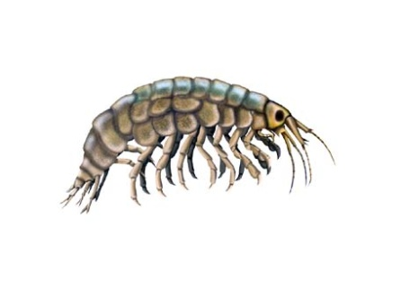
Shredders: These animals take detritus, such as leaves, and break it into smaller particles or “skeletonize” it. Microbes colonize the leaf litter first, followed by the larger invertebrates such as the cranefly, some caddisflies & stoneflies, and amphipods (at left). The crane fly breaks down the leaves from the trees and makes the energy and nutrients in the leaves available to other aquatic organisms.

Collectors (both gathering and filtering): Some organisms are filter-feeders, spinning nets to catch fine particles of detritus. Others feed on detritus at the bottom of streams and ponds. These animals include the net-spinning caddisfly, blackfly larvae, midge larvae, clams, and some mayflies. Net-spinner caddisflies construct a mesh net for filter feeding, but this net is usually destroyed during collection. Black fly larvae and midge larvae have “fans” on their heads to capture material floating in the water. Some scientists separate out the scavengers from this group, but we will include scavengers.

Scrapers: Scrapers include animals that have mouthparts they can use to graze on hard surfaces such as rocks. They have to be strong to hold onto the surface while they feed. Many of these animals have a hard shell (such as the snail or water penny) to protect them from the high energy of the water. The water penny scrapes diatoms from the surface of rocks and then eats the material as it moves, since it is sheltered from the current by the hard plates. These animals include most snails, the water penny beetle, and some mayflies.

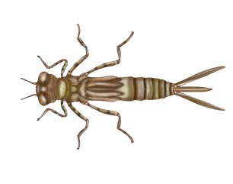
Predators: These animals have large mouthparts consisting of two opposing jaws which they use to kill other smaller invertebrates. Dragonflies, damselflies (at right), and the dobsonfly are part of this group. Dragonflies and damselflies have a large, extendable lower “lip” (labium) that can engulf very large prey, with mature dragonflies sometimes eating small fish. This lip covers the other mouthparts of the larvae, allowing it to capture large animals and tear pieces of their prey while still moving around on all six legs. Some scientists separate out parasites from this group, but we will include them here.
Decomposers: These organisms colonize leaf surfaces and use the leaves for food: microbes such as bacteria and fungi.
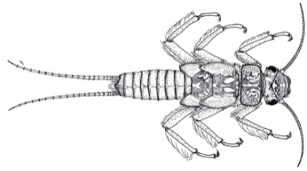
Producers: These organisms do photosynthesis. They make their own food, using sunlight to transform carbon dioxide and water into sugar plus oxygen. Producers include trees, diatoms, and algae.

Stoneflies (Order Plecoptera)- Most stonefly are predators; some are shredders. Mouthparts determine whether they are shredders or predators. Shredder mouthparts are directed downward and are shaped for cutting and grinding, while predator mouthparts project forward and are very sharp and pointed. Common prey are midges and black flies along with mayflies. Lives in water with 8-12 mg/L of dissolved oxygen.

Dragonflies (Infraorder Anisoptera; order Odonata) – Predators of anything smaller-as young larvae they eat mostly zooplankton, and as they grow larger they will eat mayflies and even small fish. Lives in water with 4.1-7.9 mg/L of dissolved oxygen.
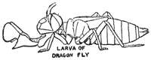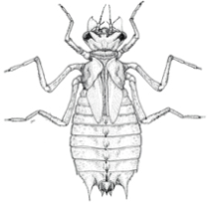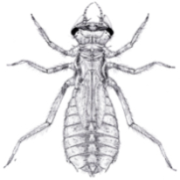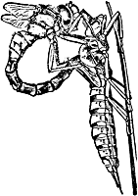

Damselflies (Suborder Zygoptera; order Odonata) – Aquatic nymphs hatch from eggs that are laid in the water. Many overwinter as nymphs, which crawl up on vegetation in the spring to emerge as adults. They are predators and live in water with 4.1-7.9 mg/L of dissolved oxygen.
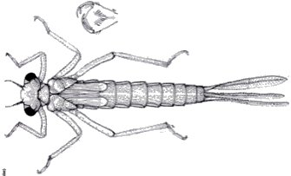

Mayflies (Order Ephemeroptera) – Overwinter as aquatic nymphs. Diet is mostly algae or detritus; mayflies are either collectors or scrapers (76% of the families are collectors, 19% are scrapers, and 5% are predators). Lives in water with 8-12 mg/L of dissolved oxygen.
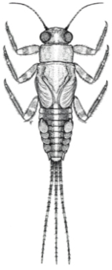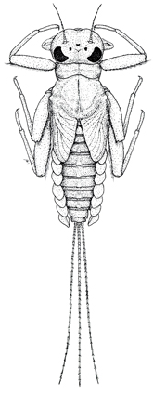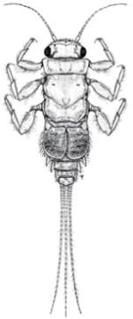
Water penny beetle (Order Coleoptera) – Flat shaped beetle that often curls up when disturbed, and has a strong grip to allow it to move across surfaces in highly turbid water. Water pennies are scrapers who graze on algae on rocks. Lives in water with 8-12 mg/L of dissolved oxygen.
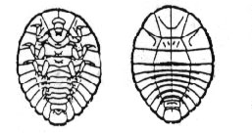
Whirligig Beetles (Order Coleoptera) - Beetles that swim on the surface or underwater and are primarily collectors. Lives in water with 8-12 mg/L of dissolved oxygen.
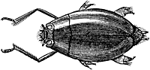

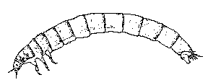
Riffle beetles (Order Coleoptera) – Small, torpedo-like larva with circular stripes or rings around the body, they are primarily collectors that eat diatoms and algae. Lives in water with 8-12 mg/L of dissolved oxygen.

Midge larvae (Family Chironomidae, Order Diptera)- Collectors that filter organic components of sediment & algae. Lives in water with less than 4.0 mg/L of dissolved oxygen.

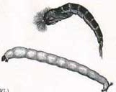
Blackfly larvae (Family Simuliidae, Order Diptera)- Collectors; they hold onto the substrate with tiny hooks and then extend a foldable “fan” into the stream, filtering particles of food (bacteria, detritus, algae) into the fan which is then scraped into its mouth every few seconds. Lives in water with less than 4.0 mg/L of dissolved oxygen.
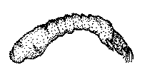
Crane Fly Larvae (Family Tipulidae, Order Diptera)- shredders; break down leaves from trees. (Crane fly from genus Hexatoma are engulfer-predators.) Lives in water with 4.1-7.9 mg/L of dissolved oxygen.
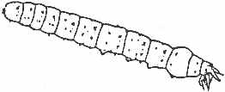
Dobsonfly larvae (also called Hellgrammite; Subfamily Corydalidae, Order Megaloptera)- Predators of any small invertebrate. Lives in water with 4.1-7.9 mg/L of dissolved oxygen.
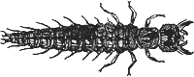

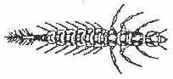
Alderflies (Order Megaloptera) – Aquatic larvae are active predators that feed on aquatic insects, worms, crustaceans, snails and clams. All are predators. Lives in water with 4.1-7.9 mg/L of dissolved oxygen.

Caddisfly larvae- case makers (Order Trichoptera)- most caddisflies that construct cases of small stones are shredders of detritus and algae. Lives in water with 8-12 mg/L of dissolved oxygen.

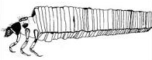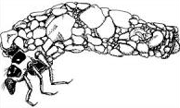
Free-living Caddisflies (Order Trichoptera)- are mostly predators of smaller invertebrates or scavengers. Lives in water with 8-12 mg/L of dissolved oxygen.
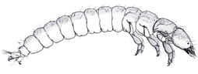
Net spinner Caddisfly (Order Trichoptera; Family Hydropsychidae) – Collectors who spin nets to catch fine particles of detritus. Lives in water with 4.1-7.9 mg/L of dissolved oxygen.
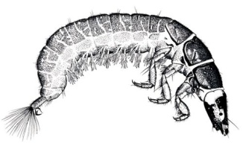
Scud (Order Amphipoda; also called sideswimmers and amphipods)- Shredders who eat mostly detritus, algae, bacteria, and any recently dead organisms. Lives in water with 4.1-7.9 mg/L of dissolved oxygen.
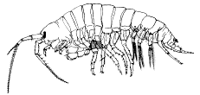
Sowbugs/Pill bugs (Order Isopoda) – Eat a variety of decaying organic matter. Most are collectors. Lives in water with 4.1-7.9 mg/L of dissolved oxygen.
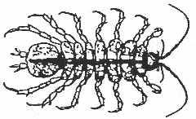

Crayfish (Order Decapoda)- omnivores, primary food is decaying vegetation but will eat anything they can subdue; they are predators and collectors (scavengers). Lives in water with 4.1-7.9 mg/L of dissolved oxygen.
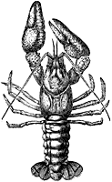
Spiders (Class Arachnids) - Feed by sucking the body fluids from their prey; predators.
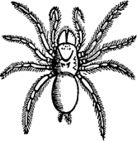
Snails (Class Gastropoda) – Snails scrape algae and other organic matter from ponds substrates. Most snails are scrapers. Gilled snails live in water with 8-12 mg/L of dissolved oxygen, lunged snails can live in water with less than 4 ml/L of dissolved oxygen.
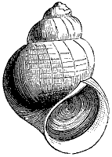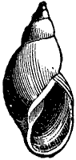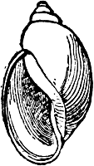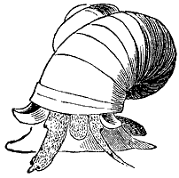
Clams and mussels (Class Bivalvia) – Clams & mussels are filter feeders that live on phytoplankton, zooplankton, detritus and bacteria. They are collectors. Lives in water with 4.1-7.9 mg/L of dissolved oxygen.
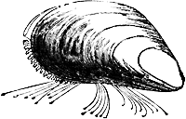
Leeches (Subclass Hirudinea) – Worm-like, soft-bodied organisms with not legs and suckers at either end of the body that attach to hosts and suck fluids from other animals. They are predators (or parasites). Lives in water with less than 4.0 mg/L of dissolved oxygen.
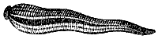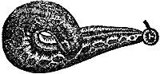

Aquatic Earthworms (Order Oligochaeta) – Most eat detritus, algae and bacteria; these are collectors. Lives in water with less than 4.0 mg/L of dissolved oxygen.
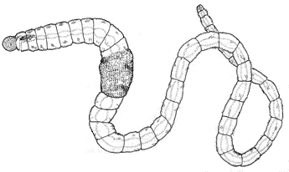
Planaria (Class Turbellaria)- Also called flatworms; predators of soft-bodied invertebrates.
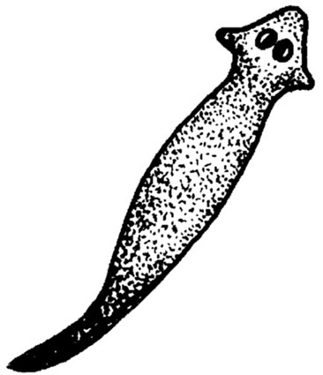
Small arthropods and other protists: mostly consumers (omnivores) that eat small arthropods, protists, bits of detritus, algae etc.

Water mite (Subclass Acari) – These small, tick-like animals live on land and in water. They are parasites or predators of other organisms.
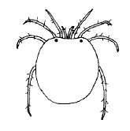
References:
Voshell, J.R. 2002. A Guide to Common Freshwater Invertebrates of North America. McDonald &
Woodward Publishing Company, Virginia.
Thorp, J.H. & A.P. Covich. 2010. Ecology and Classification of North American Freshwater
Invertebrates. Elsevier, Amsterdam.

Appendix C Dissolved Oxygen teaching materials
Dissolved Oxygen
Oxygen is important for many living things and for many of the chemical processes that happen in the water. There are two ways that dissolved oxygen enters water, either from photosynthesis from aquatic plants or through diffusion with the surrounding air. Wind, waves, and bubbling can increase the amount of oxygen that enters the water from the surrounding air. Oxygen is also taken out of the water by cellular respiration of aquatic animals and plants, decomposition of organic matter by microorganisms, and different chemical reactions.

Dissolved oxygen is measured in a few different ways: parts per million (ppm), milligrams per liter (mg/L), or percent saturation. When measuring DO, concentrations range from 0 to 14 ppm or mg/L (they measure the same thing, but sometimes your test kit will use only one of the measurements), and 0-125+ percent saturation. When measuring percent saturation, you also need to know the temperature of the water, because that can change the result.

For mg/L:
0-2 mg/L: not enough oxygen to support most animals
2-4 mg/L: only a few kinds of fish and insects can survive
4-7 mg/L: good for most kinds of pond animals
7-11 mg/L: very good for most stream fish
For percent saturation:
Below 60%: poor quality, bacteria may be using up the DO
60-79%: acceptable for most stream animals
80-125%: excellent for most stream animals
125% or more: too high

When water has high, relatively stable levels of DO, it is usually considered a healthy ecosystem, capable of supporting lots of different kinds of organisms. Low DO (usually called hypoxic) levels usually indicate pollution or some type of human-caused change, of which there are several major categories:
- Addition of organic waste in the form of sewage and animal manure, organic fibers from textile and paper processing, and food wastes. These organic materials are decomposed by microorganisms that use up oxygen.
- Addition of nutrients from fertilizers and agricultural runoff as well as through sewage. This causes lots of plants and algae to grow and then decay. The bacteria that decompose the plants consume oxygen during the decay process
- Changing the flow of the water through dams and water withdrawal (for irrigation, snowmaking, water supply, or cooling systems of electric or nuclear power plants). The reservoirs created through a dam may increase the temperature and reduce the amount of dissolved oxygen.
- Raising the water temperature through the removal of vegetation from stream banks, which increases the water temperature and therefore decreases the dissolved oxygen levels. Another way that temperature can be affected is through the release of heated water that was used to cool an industrial plant.

Natural processes also affect the dissolved oxygen levels:
- Warm water holds less dissolved oxygen than cold water.
- The lowest levels of DO usually occur in the morning, because photosynthesis stops at night while respiration continues.
- Water at higher altitudes holds less oxygen.
- Fast-moving water generally has more oxygen than still water, because the movement mixes the air into the water. However, if the water is very turbulent, it may hold too much oxygen, causing stress to the aquatic organisms.
- Water with lots of aquatic plants have higher levels of dissolved oxygen, since submerged plants produce oxygen through photosynthesis. Also, as mentioned above, too many plants will ultimately reduce the DO levels, because of either night-time oxygen use by plants or the decay process that consumes oxygen.

Anoxic means that the water doesn’t contain any dissolved oxygen. Some animals, like carp and catfish, can survive with less oxygen, while others, such as salmon and trout, require more. When DO becomes scarce, some animals may be able to obtain their oxygen directly from the surface, such as the diving beetle, frogs, or even catfish. Testing water samples for DO will let you know what kind of organisms can live in the water.

- Where does the oxygen come from that aquatic organisms need?

- What are two ways that dissolved oxygen enters the water?

- How is oxygen used in the water (consumed)?

- Give three examples of how DO levels can change due to human interaction with the aquatic ecosystem.

- Explain 2 ways nature may affect the DO levels in an aquatic ecosystem.

- What levels of dissolved oxygen are “very good” for most aquatic organisms?

- Explain the daily cycle of dissolved oxygen levels in an aquatic ecosystem.

Appendix D CA State Standards Addressed
California Science Content Standards | Environmental Principals & Concepts Learning Objectives
Seventh Grade
Evolution
3. Biological evolution accounts for the diversity of species developed through gradual processes over many generations. As a basis for understanding this concept:
a. Students know both genetic variation and environmental factors are causes of evolution and diversity of organisms. | - Identify the role of environmental factors on the evolution and diversity of organisms, and the long-term functioning and health of natural systems.
e. Students know that extinction of a species occurs when the environment changes and that the adaptive characteristics of a species are insufficient for its survival. | - Define and give examples of adaptation in living things.  - Explain the effects of changing environmental factors in a natural system on species (e.g., changing biotic and abiotic factors including the availability of resources).  - Recognize that throughout the history of life on Earth, some plants and animal species have died out completely in response to environmental changes.

Structure and Function in Living Systems
5. The anatomy and physiology of plants and animals illustrate the complementary nature of structure and function. As a basis for understanding this concept:
a. Students know plants and animals have levels of organization for structure and function, including cells, tissues, organs, organ systems, and the whole organism.
Investigation and Experimentation
7. Scientific progress is made by asking meaningful questions and conducting careful investigations. As a basis for understanding this concept and addressing the content in the other three strands, students should develop their own questions and perform investigations. Students will:
a. Select and use appropriate tools and technology (including calculators, computers, balances, spring scales, microscopes, and binoculars) to perform tests, collect data, and display data.

California Science Content Standards | Environmental Principals & Concepts Learning Objectives
Seventh Grade (Continued)
- Communicate the logical connection among hypotheses, science concepts, tests conducted, data collected, and conclusions drawn from the scientific evidence.
Eighth Grade
Investigation and Experimentation
9. Scientific progress is made by asking meaningful questions and conducting careful investigations. As a basis for understanding this concept and addressing the content in the other three strands, students should develop their own questions and perform investigations. Students will:
a. Plan and conduct a scientific investigation to test a hypothesis.
c. Distinguish between variable and controlled parameters in a test.
Grades Nine Through Twelve
Biology/Life Sciences - Ecology
6. Stability in an ecosystem is a balance between competing effects. As a basis for understanding this concept:
a. Students know biodiversity is the sum total of different kinds of organisms and is affected by alterations of habitats. | - Define biodiversity (biological diversity) as a measure of the different kinds of organisms in an ecosystem.  - List the direct and indirect changes to natural systems that can affect biodiversity (e.g., alterations of habitats).  - Describe the implications of loss of biodiversity to natural systems and human societies.
b. Students know how to analyze changes in an ecosystem resulting from changes in climate, human activity, introduction of nonnative species, or changes in population size. | - List variables that can cause changes to ecosystems (e.g., climate change and human activities such as the introduction of nonnative species and the conversion of land [loss of habitat]).  - Provide examples of how each of these variables can lead to changes in ecosystems.
e. Students know a vital part of an ecosystem is the stability of its producers and decomposers.
California Science Content Standards | Environmental Principals & Concepts Learning Objectives
Grades Nine Through Twelve (Continued)
Biology/Life Sciences - Evolution
8. Evolution is the result of genetic changes that occur in constantly changing environments. As a basis for understanding this concept:
a. Students know how natural selection determines the differential survival of groups of organisms. | - Identify the natural factors that can influence the rates at which environments change.  - Recognize the natural factors that can influence the differential survival of groups of organisms.
b. Students know a great diversity of species increases the chance that at least some organisms survive major changes in the environment. | - Recognize that biological diversity worldwide varies greatly in different biomes.  - Explain why the geographic extent and biological diversity of ecosystems varies in different biomes.  - Describe naturally-occurring factors as well as human activities and practices that can influence the species composition and geographic extent of an ecosystem.  - Explain that high biological diversity increases the chance that at least some organisms survive major changes in the environment.
Investigation and Experimentation
1. Scientific progress is made by asking meaningful questions and conducting careful investigations. As a basis for understanding this concept and addressing the content in the other four strands, students should develop their own questions and perform investigations. Students will:
a. Select and use appropriate tools and technology (such as computer-linked probes, spreadsheets, and graphing calculators) to perform tests, collect data, analyze relationships, and display data.
d. Formulate explanations by using logic and evidence.

You can choose to take your students (or a subset) to the stream 0, 1, or 2 times but you or someone you trust (e.g. a GK-12 fellow, TIR, your spouse) need to go to the stream twice: once to place the leaf pack bags and another, 3-4 weeks later, to pick them up.
? Instructional day 2 needs to be 3-4 weeks after you or the students place the leaf pack bags into the stream. If you plan for students to be involved/or feel involved in designing the experiment and placing the bags in the stream, instructional day 1 must take place 3-4 weeks before instructional day 2. If you want to present day 1 immediately preceding day 2, you can set up the experiment 3-4 weeks before day 2 and present the experiment to the students, cooking-show style.
? MS= middle school, grades 6-8; EHS= early high school, grades 9-10; AHS= advanced high school, grades 11-12, AP, IB. The unit is designed for MS and EHS students to do and experiment with one factor (two places in the stream). If you feel your 9th and 10th grade students are high performing, you may choose to do the more complicated 2 factor experiment (two types of leaves, two places in the stream) with them.
For more information on the 5E learning cycle see http://enhancinged.wgbh.org/research/eeeee.html
? You may also decide to design an experiment that test location (locally—e.g. differing land uses around streams and nationally—e.g. differing latitudes, urban v. rural) by sharing data and leaves with teachers in your local network or the national MSP network (CA, CO, MI, MD, NY). Contact us if you want to include these data in your classroom work.
www.towson.edu/csme/mctp/Journeys/Flowingwaters.doc
If you don’t do the set up in class, you will still need these supplies to set up the leaf packs yourself.
If you don’t do the set up in class, you will still need waders or appropriate shoes to collect the experiment yourself.
Stroud’s Leaf Pack Network ® Manual http://www.stroudcenter.org/lpn/LPNmanual/index.htm

